Proactive Operations
Part 2 Chapter 1
Proactive Operations is a complex concept. How does it work in real life?

System Engagement
As a product, how does VCF Operations “communicates” to its users?
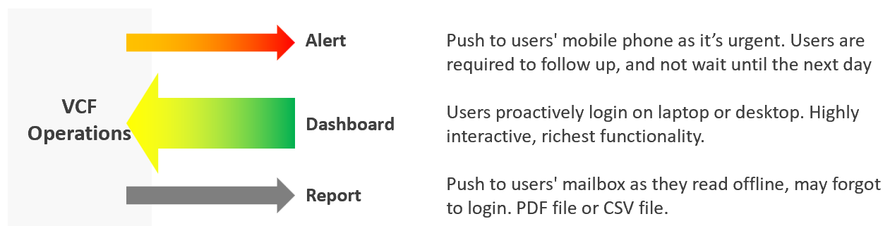
In terms of urgency, live screen is the most pressing, followed by alert. Report is suitable for long term review. Use dashboard as much as possible as it offers the richest functionality and interaction. That’s why the diagram above shows it with bigger arrow than the other 3 ways.
If you apply the above thinking, you will vrealize several benefits:

Less reports | Encourage users to login as they get richer experience. Compliment with login-less dashboards, made available at user-friendly intranet website
Higher engagement | Higher engagement with IT Leadership Team. Take time to educate and demonstrate how dashboard meets their needs better. Use a login-less dashboard, displayed prominently near their office to encourage involvement.
Better telemetry | It’s not possible to track if users actually read your reports. With dashboard, you can even track how they interact with VCF Operations, using 3rd party website tracker software.
Flexible threshold | You can tailor the threshold (green – yellow – orange – red) accordingly, as each of the 4 way of communication have different level of urgency.

Synergy
The following table details how the 3 ways of engaging are complementary. I’ve excluded screen as it has narrow usage.

 | Alerts | Dashboard | Report
Nature | Reactive | Proactive | Passive
Good For | Exception | Exception.  Analysis | Exception.
Depth | Detail | Detail and Summary | Summary
Use Case | Troubleshooting | Troubleshooting.  Monitoring.  Optimizing | Export to spreadsheet or PowerPoint
Time | Minutes | Daily – Monthly. | Weekly onwards
Time | Focus is “now” | Focus is days | Focus is weeks
Roles | L1 | L1 onwards | IT Leadership
Roles |  | Architect Team | Finance Team
Roles |  | Capacity Team (Dashboard + Report work together)
Roles |  | Audit Team (Dashboard + Report work together)
Roles |  | Tenant (Dashboard + Report work together)

Timeline
In VCF Operations, the following are implemented as dashboard:
- NOC screen
- Daily health check
- Longer cadenced
However, they have diferent timeline. As a result, they have different purpose.

 | Live NOC Screens | Daily Preventive Check | Longer Cadence
Purpose | Real time visibility into the overall environment, so live fire is attended right away. | Prevent alerts of the day. Tomorrow is another day as it will be checked tomorrow morning. | Larger optimization and issue avoidance. Deep and broad analyzis of the whole environment.
Purpose | Urgent (hopefully not important) | Important (hopefully not urgent) | Important (definitely not urgent)
Timeframe | Focus: last 5 minutes | Focus: next 12 hours | Focus: Weekly – Quarterly
Timeframe | Data: 1 hour | Data: 1 week | Data: 1 year
Usage and Interaction | Live. Always on and projected on the big screen. | 2x a day. Once at start of day, the other at end of day. | Less standard.  Multiple usage throughout the week/month, depending on the persona and need.
Usage and Interaction | Time spent to analyze: 10 seconds | Screentime: 10 minutes
User | L1 (first liner) | L2 (expert) | Auditor, Capacity Planner, Performance Specialist, Cost Specialist
Primary Content | Availability. Performance. Security. | Same area of concern, but the Daily Check is broader and deeper as it has much longer horizon. | Capacity (utilization, reclamation, optimization).  Sustainability.

How are their differences translating in the product UI?

Live NOC Screens | Daily Preventive Check | Longer Cadence
Dashboard size matches the projector/TV. No scrolling. | Dashboard size is 1 -2 screen deep. | Dashboard size is >2 screen deep.
Table not suitable. Hard to conclude by seeing many numbers.  Easier to see trends + present number | Scoreboard is suitable, as L2 will click to do interactive filtering and analysis | Table for export to spreadsheet for further analysis
No interaction as there is no keyboard/mouse. See from a distance. It auto-refreshes and auto-rotate | Standard interaction process | Rich interaction. Flexible flow, depending on the need at that time

Live Screen
The real-time nature of life inside the Network Operations Center room calls for a different type of visibility.
Collaborate with NOC Room team, as they are ultimately the consumer. What information do they need? What do you need from them? What’s the Exit Criteria and Entry Criteria?
The following diagram summarizes the key requirements and constraints. As a result, the dashboard needs to be designed accordingly.
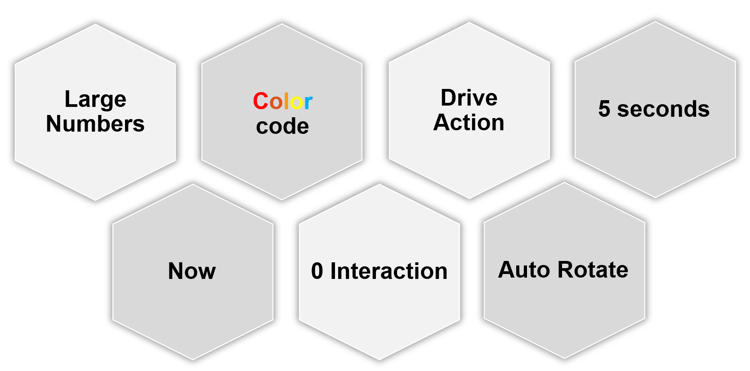

0 interaction | Think of TV, not monitor. NOC screen does not have keyboard and mouse for user to click and type. So the information is auto-refresh and auto-rotate.  If your TV has a touch screen, that’s a bonus. This should not replace the basic need of being useful from afar.
0 interaction | Toolbars & buttons on screen should not be used. They add confusion, plus there is no way to use them from afar.
0 interaction | Most widgets are not suitable as a result.
Large Number | As the information is seen from a distance, the font used is much larger than the standard font used in laptop or desktop monitor. This also means the screen real estate is relatively less. When designing, use a 14” screen instead of 24” screen.
Now | It is placed strategically because it displays a time sensitive information. As such, many operational use cases are actually not suitable for these. For examples, Capacity, Cost, and Sustainability management are not highly time sensitive. They tend to stay static for hours, rendering them unsuitable for live screen.  It’s showing the latest 5-minute data. The past is less relevant. Ideally, project the next 1 hour.  The information auto-refresh frequently. Think 1 minute, not 10 minutes. If the display is static for 300 seconds, users will not be drawn into it.  The information presented is more urgent in nature than alerts (otherwise you simply use alerts!) and is used to complement alerts.
Color | Heavy use of color. Color is easier to digest than text, as you don’t even need to read. Lots of text can confuse viewers. Text can be hard to read from afar.  Use key colors (green, yellow, amber, and red) classify the severity of the issue.  By default, all should be green. If you display something that is red most of the time, after a while the viewer will ignore it. This defeats the very purpose of displaying on the big screen. Use alerts for something less urgent.  Ideally, all the numbers are in %, with 0 being bad and 100 being perfect.
5 second | KISS (Keep It Simple Show). Remember the 5-second test.  The screen should be easy to interpret, user friendly and do not require an explanation.
The above principle applies to the part of the dashboard that is projected on the big screen. You can dual-purpose the same dashboard, to cater for the operators in the NOC room. These help desk administrators should have the same dashboard on their desktop or laptop. They can then use keyboard and mouse to interact with the dashboard, enabling them to drill down and find out more information.
I’m aware that other persona, especially IT leaders, may drop by to NOC room to check things out. This does not mean we design a NOC dashboard for them. For example, say CIO drops by every single day for 10 minutes. In this case, if it makes life easier, prepare a dashboard to facilitate the “check”. Only bring up during the visit. There is no need to have the dashboard on the wall for the remaining 23:50 hours.

Action
Action, not information. NOC show data for your action, not for your information.
Focuses on immediate remediation. Remediation action has to be immediate, as soon as possible if it’s red.
If something can’t be fixed within the same day, why show it live? Remediation that takes >1 day should not be shown, as the dashboard will be red for hours. Use alerts for longer remediation window.
Problems that don’t require immediate attention should be avoided, as they are distraction. Your NOC Screen is not your To Do List.
Examples of suitable actions: stop provisioning of new VM, take action on VMs that abuse the shared infrastructure.
Examples of not suitable actions: Increase supply of infrastructure, such as adding hardware.

Auto Rotate
It’s not enough to auto-refresh due to the sheer amount of information. Auto-rotate enables you to show more content without scrolling the dashboard, and prevent human’s boredom from seeing the same screen for hours.
Configure the dashboards to auto-rotate in a logical flow. Explain the flow to the users as it can get overwhelming.
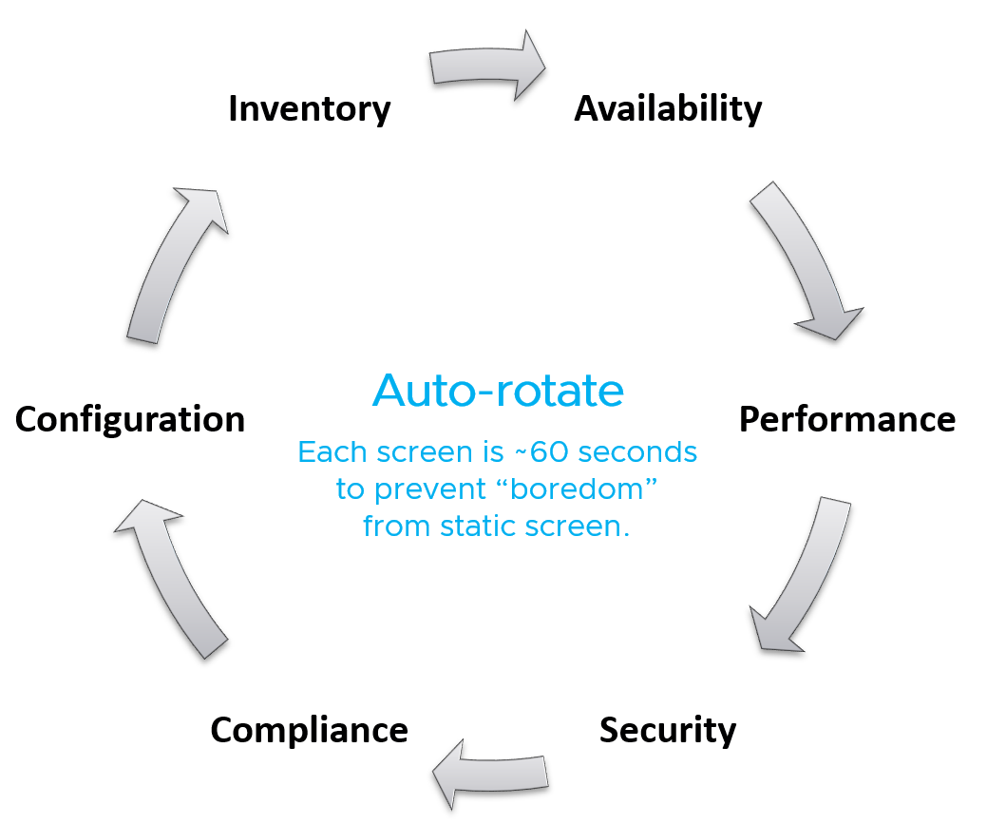
Implementation wise, you need to disable Guest OS screen saver, Aria Operations user time out and Guest OS going to sleep.
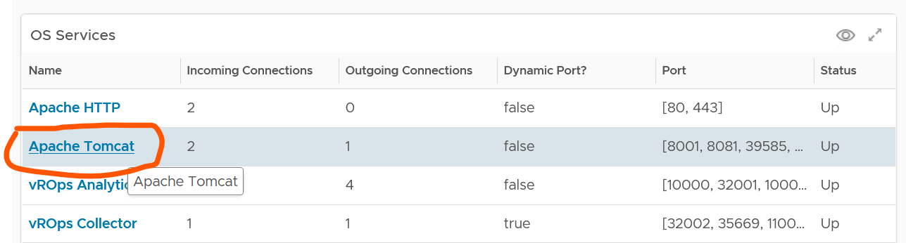

Daily Health Check
This daily, proactive health check forms the 2nd leg of your proactive management.
Start each day with a proactive daily health check. Initially, this is done by both Level 2 and Level 1 team. As Level 1 gain confidence, they may even do it at the start of their shift. As there are 2-3 shifts in 24/7 operations, the dashboard gets used multiple times a day. The dashboard aims to minimize alerts by analysing underlying issues, hence it requires expertise of how your private cloud performs. It also requires someone who knows the environment well, especially what is happening on that day that can impact performance and security.

Morning Routine
As the person responsible for the health of the overall environment, what do you check every morning, with your first cup of coffee?
If the answer is a list of alerts or complaints, how do you know the big picture?
By and large, your environment is good, otherwise you’re not reading this specific chapter 😊. If it is not good, you have some knowledge on the problems as you need to explain it to your management. On this assumption, this dashboard focuses on things that need attention.
It complements alerts by showing insights (situation that has not triggered an alert) and show the overall picture. The overall picture is also useful as before you troubleshoot something specific you should ensure the issue is not with the overall environment.
As insights complements alert, open the 2 screens side by side. Simply open 2 browser windows, as shown in the following screenshot.
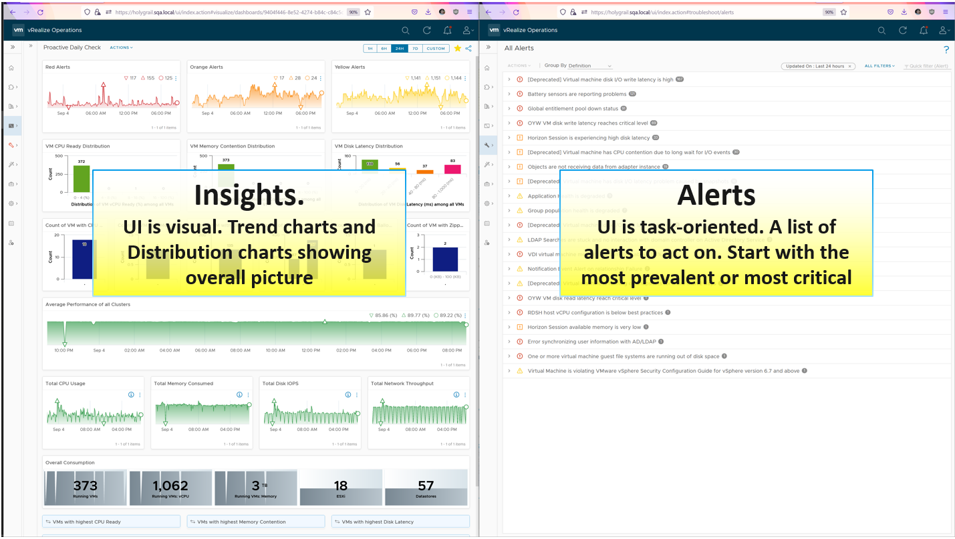
There are 2 dashboards, one from VCF Operations and one from Log Insight.

vSphere Daily Log Check
A lot of information is only available in the form of logs. Use a daily Log Insight dashboard to perform basic hygiene, such as:
- Undesirable VMs events. Are they in line with your expectation? That means the correct amount and right timing. Harmless events such as VM relocation, snapshot, powered on were filtered out from the dashboard.
- Undesirable VM changes & Snapshot. Are they in line with your expectation? Harmless changes filtered out. Are changes and snapshot taken during office hours?
- Issue. vCenter Alarms, vCenter tasks that ended with error, and ESXi potential problems.
- Security. Any malicious changes? Anyone issuing shell commands at ESXi console? Login by root?
- vMotion. This is a leading indicator of a larger performance issue. Is the bandwidth lower than expected? Is the downtime longer than expected? Some clusters did a lot more vMotion than usual?

Business Applications
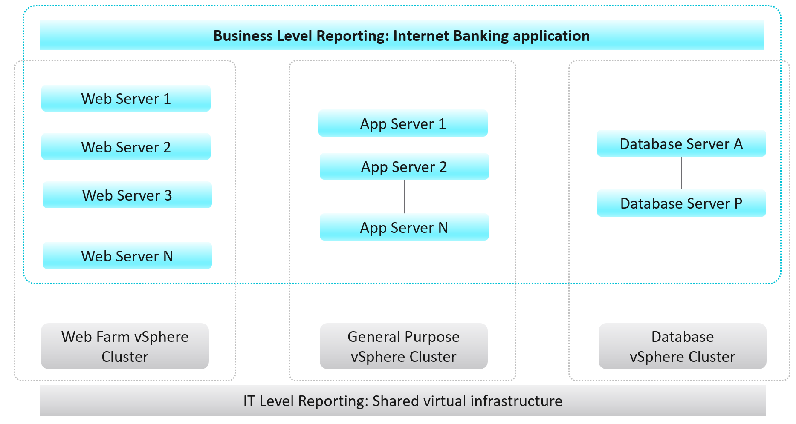
There is a need for more in-depth business-oriented reporting focused on logical business constructs such as services, applications, departments, divisions, teams, groups, or any other type of logical business structure. Quantifying performance, capacity, and cost at the logical business unit level makes more relevant information to business leaders. This is because services, applications, and business units can span multiple infrastructures from private, through hybrid, to public. Not only is business-oriented reporting more intuitive for a business to consume, it also makes the IT more transparent and aligned with actual business outcomes.
Frequently, business unit stakeholders will ask IT to provide reporting around their workload’s performance, capacity, configuration, and cost. For example, a business owner may ask the following questions:
- What is the infrastructure cost for an application, service, or department?
- What can we do to reduce the infrastructure costs of our service/application?
- How much compute and storage are our application/service consuming?
- What are the poorly performing VMs in an Application Stack and why?
These questions are mostly about the underlying infrastructure, but instead of being posed at a vSphere level, they are positioned around the business applications. Traditionally, it has been very difficult for IT to answer these types of questions because typical Element Managers used by IT, represent various objects in a very rigid hierarchical fashion that does not translate well to the elastic business structure.

The Crown Jewel
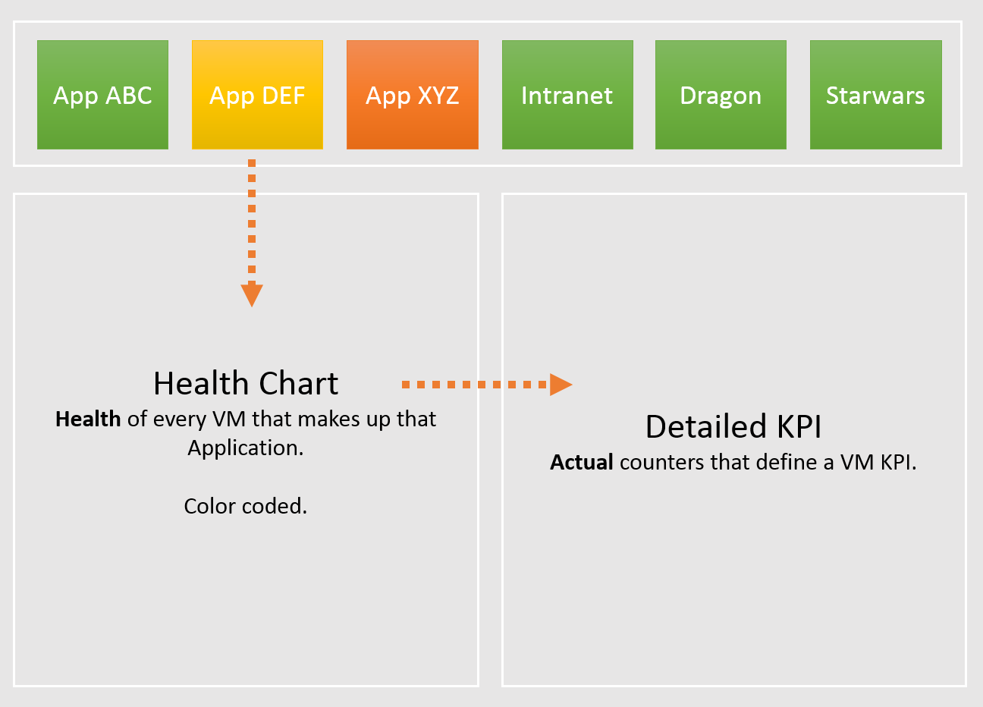

vSphere Folder Structure
To implement the above, the first step is to design a vSphere folder structure that reflects the organisation structure. These folders and their relationships are then used by VCF Operations groups and business applications.
The following structure shows Business Unit as the top folder. Each business unit can have 1 or more departments (Business Unit C spans 3 departments in the diagram below). Each department owns multiple business applications. A business application typically consists of multiple tiers (e.g. web tier, application tier, database tier). A tier is a group of VMs performing the same function, running the same set of software and have identical hardware configuration. You expect the VMs are either scale-out (farm) or active/passive.
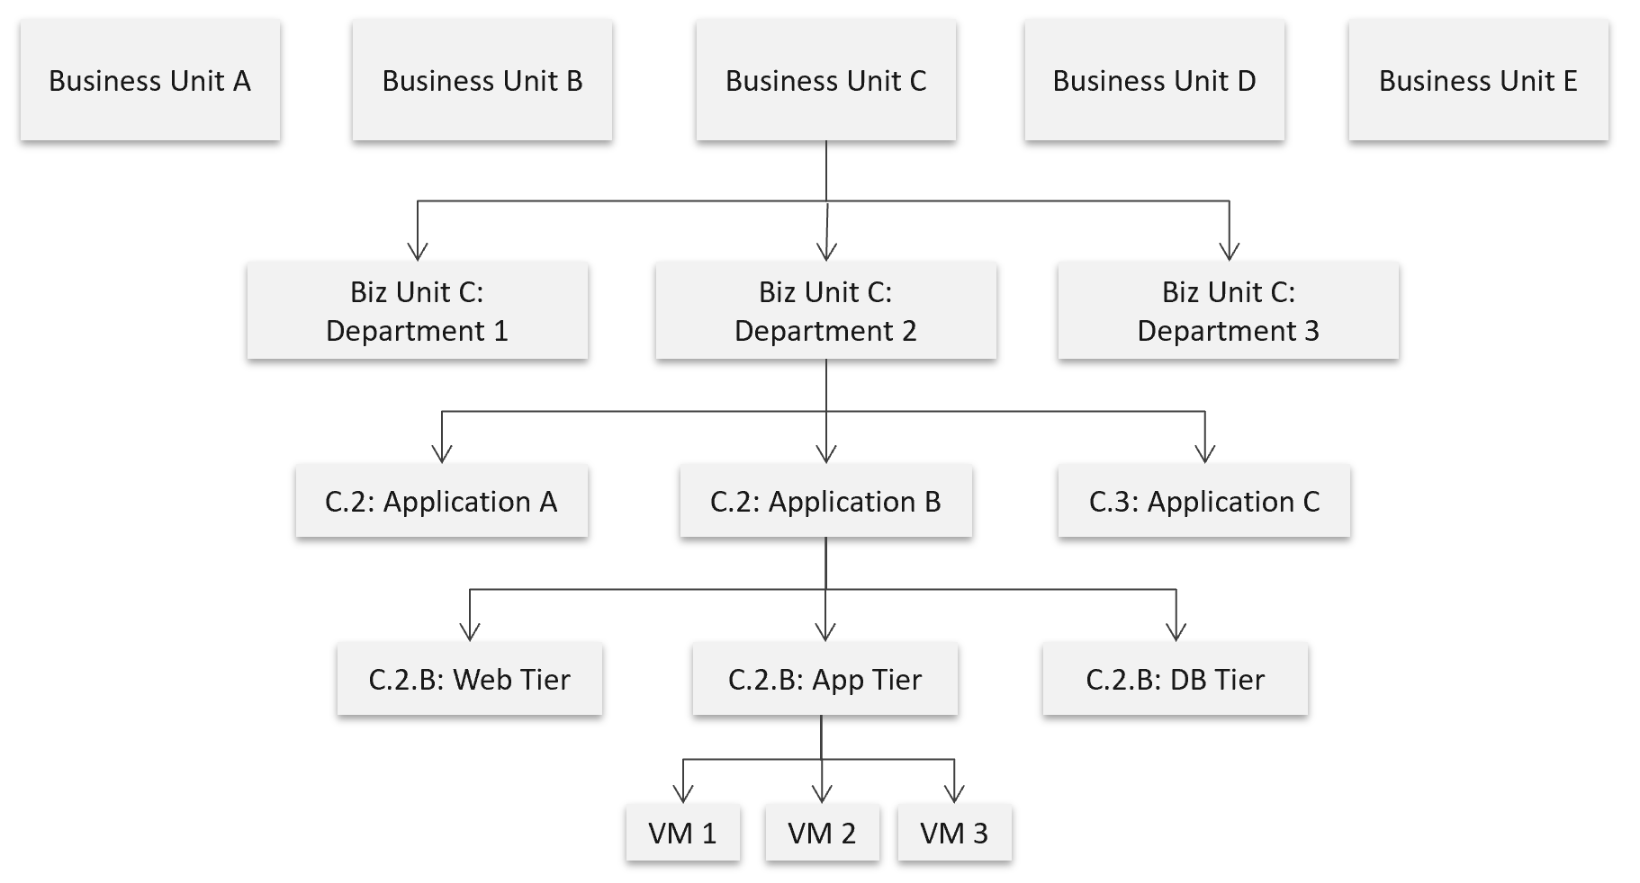

The limitation of the above is reorganisation. You will need to rename, move folders to the new parent folders, and delete folders that are no longer relevant. For example, if Business Unit B merges with Business Unit C and the combined entity has a new name, then you need to rename one of them, and delete the other. This is why I only have 2 levels of organisation in the above. Your goal is to have some level of context, not to replicate the entire organisation chart as that’s the job of HR department😊
The application name should be unique. If not, prefix with the department name.
The folder name needs to be unique, even across vCenter Servers. So, it’s paramount to have the application name as prefix.
If you have multiple vCenter servers, the name should be consistent across all of them.

Objects Design
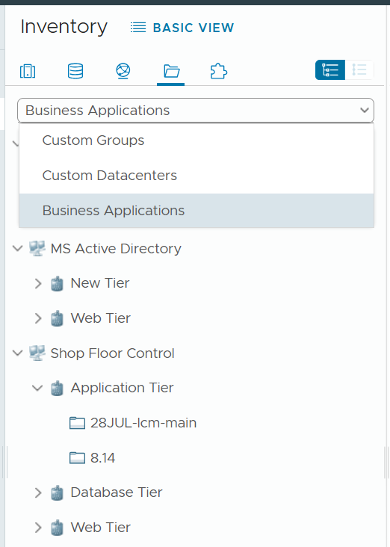 | Business application is not an object that belongs to vSphere or VMware. It can potentially contain objects outside VMware objects. So the parent object is different. It’s called Entire Enterprise Applications, as shown on the following screenshot.

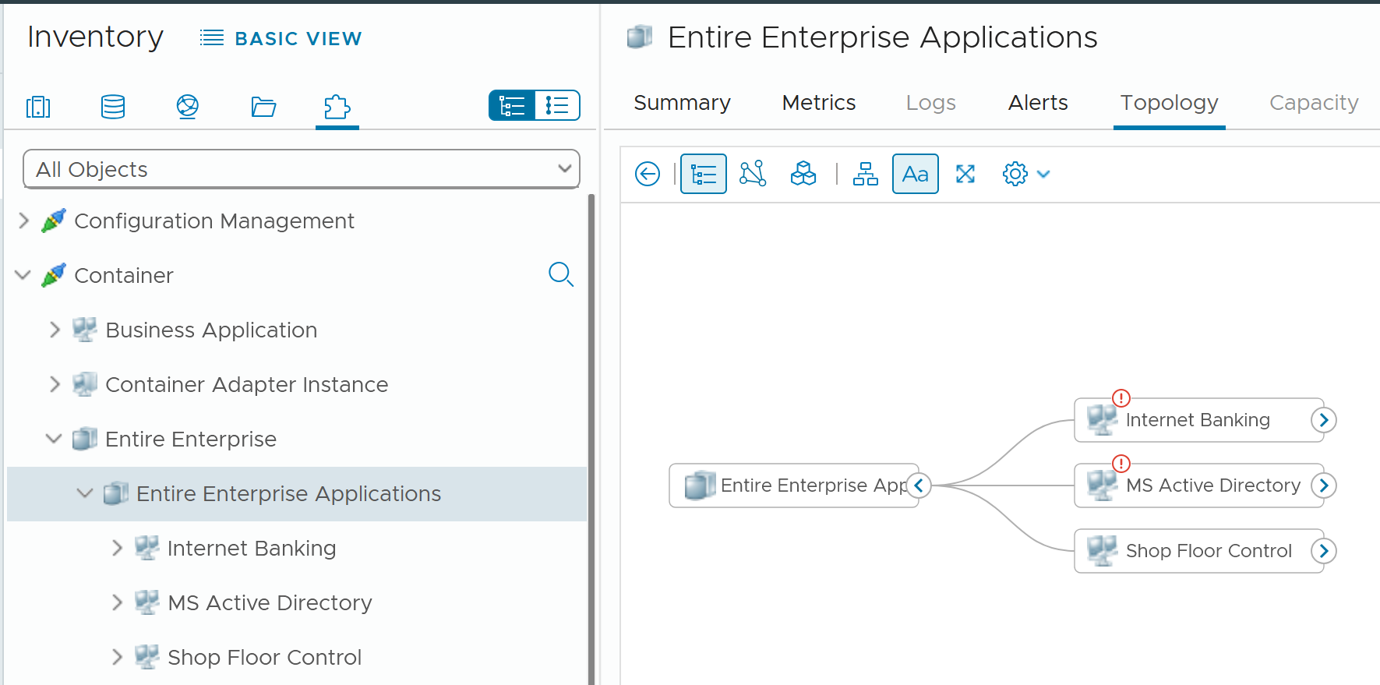
In the screenshot, you can see the structure that it’s a parent of 3 business applications
Limitation: The tiers are manually added. It has no dynamic membership the way Custom Groups has.

Alert
Managing alerts is not the same as minimizing alerts. Managing is dealing with alerts that are already triggered. Minimizing takes us towards preventing alerts to begin with. Use insight to minimize alert definition, as alert should be reserved for urgent and important issue.
Your goal is to minimize alerts storm while providing the broadest coverage. This calls for a careful planning on the alert definition, symptom and threshold.

Alerts Planning
For each alert, ask yourself: what action must be taken, today, by the person seeing the alert?
- If the answer is nothing, then why disturb the person today? He will be bombarded with early warnings. Dashboard gives better picture as it shows issues that are yet to breach the threshold.
- If the answer is something, can that action be automated? If the answer is yes, then why do you want to be alerted? You should automate the response. Be careful of simplified logic as computer has no common sense. An automation that is not fool proof can result in a disaster.
If the answer is escalating to the next level (e.g. Level 2 support) after adding some context and initial analyzis, then it depends on the urgency. Generally speaking, L2 has longer timelines and need to see bigger picture. So the L1 frontliner may group the alerts into 1 instead of escalating each as isolated cases. If this is the case, help the L1 to see the big picture. A dashboard is more effective.

Target Persona: The Who
It is essential to design the alert for each persona. What is relevant for one may be irrelevant to others.
There are at least 3 main personas, with additional sub-personas:
- Application team
- Infrastructure team. This is the main persona, but it has at least the following sub-personas:
  - Network Team
  - Storage Team
- Security team. They look at both, but purely from security perspective.

Class of Service: The What
Not all workloads are equal. The mission critical applications are certainly more important than its development version.
Classify your workload into 3:
- Mission critical applications
- Standard production
- Test and Development
Having more than 3 can complicate operations.
Tailor the alerts according to the class of service. The higher the criticality, the lower the threshold. For example:
- Mission Critical: VM Disk Latency > 30 ms for 5 minutes.
- Standard Production: VM Disk Latency > 60 ms for 10 minutes.
- Test and Development: VM Disk Latency > 120 ms for 10 minutes.

What to Alert
What areas do you want to monitor with alerts? What can you do to reduce the noise?
Define the types of problem for each pillar of operations. For each type, classify if an alert is needed or not.

Availability | Proactive hardware replacement before reaching the manufacturing limit. For example, the SSD disk has limit of number of writes as each write introduces wear and tear. The manufacturer has a number in mind for endurance. If you have thousands of disks, you create a weekly dashboard just to track this limit and schedule proactive replacement for those disks nearing their limit.
Availability | Check the hardware temperature as heat is the #1 enemy of electronics. Okay, if you have water leakage you have a different problem
Availability | Ensure software stack compatibility as versions incompatibility is known to cause outage.
Availability | Have redundancy, so unplanned downtime triggers non-critical alerts so long it’s within the allowance set in the design. If you design N+1 availability, then a single downtime is not a red alert
Availability | Trap soft errors. They are non-critical events that act as early warning. Treat them as insights.
Performance | Minimize reactive operations not by using lower threshold as that will result in noise. Instead, track early warning metrics via insight.
Performance | For consumption type of alerts, only define red alerts. Orange level is best covered by daily dashboard.
Performance | For contention, suppress for low utilization, as likely the impact is not felt at the application level. Use CPU as the proxy for application.
Performance | Daily check for sustained and high utilization, especially those trending upwards over time.
Performance | Separate formal SLA (alert) with internal KPI (insight).
Security | Security attack. If the attack is live, the alert screen needs to be accompanied by NOC screen.
Security | Check for undesirable events
Configuration | Only high-risk settings that cause urgent problems such as slow performance, outage, or security hacking.  Non-urgent config issues are best managed via daily health check.
Compliance | Only the urgent one, where you cannot wait until tomorrow
Capacity | Only define red alert as it’s a guard rail.

Alert should not replace operations best practices. For examples, you should ensure VMware Tools are up to date. If you set an alert for outdated VMware Tools, you become reactive and may get excessive alert. Since it’s not urgent, it’s better to have a daily SOP where you have a list of VMs with outdated VMware Tools. Make sure the list is empty.
Alert should be triggered on all affected objects, both the victims and the villain. It is common that a failure at the lowest ripples through the upper layers. For example, a physical disk failure in a vSAN cluster. This in turn can bring down an entire vSAN disk group. If the ESXi host has only 1 disk group, it can impact the host as it will have no storage.

What not to Alert
Do not set alert on issue that you can review the next day. You’re better off with a daily dashboard, as it lets you see the big picture.

Availability | Backup failure. For example, you do nightly back up of 1000 VM and 1 fails. Since you still have the previous night backup, you don’t need to troubleshoot at night. The exception here is there are many VMs affected.
Cost | Nothing urgent.
Inventory | Since there is already a NOC screen tracking inventory volatility, you don’t need an alert here as inventory it’s merely an account of what you have. There is no good or bad.
Capacity | Reclamation and downsizing is best done via daily dashboard.  This is often mistaken as performance problem, as high utilization is a common alert.
Configuration | Non-urgent issues, such as outdated VMware Tools.
Compliance | Non-urgent issues, such as non-security compliance to corporate standard.

Examples of important but not urgent:
- “Host is in maintenance mode for at least 72 hours” is not urgent as it’s been down for 3 full days. It’s important as that’s not normal.
- “A recoverable memory error has occurred on the host” is not urgent as the issue has been recovered. You likely need to replace hardware. As the problem can spread, it’s an important one. You need to schedule a hardware scan, which may require a schedule downtime.
- You notice vMotion has been taking 300% longer in the last 12 hours, going up from the usual 0.2s to 0.6x second in 10 large clusters, where a total of 10K production VMs are running. But it’s a low level issue that none of the app owners have not noticed. Not urgent, but important as it can potentially turn into a big problem.
- You notice a performance problem that has happens randomly. It went away by itself within 5 minutes, so the owner kind of forgive your IaaS. But the problem hit VMs randomly, and it’s been going on a few times a day for a few days. Different owners are impacted so each does not really complain as each is rarely hit. You feel it’s risky to add more VMs.

Design
Design the alerts as a set.
- Start with the 4 elements of infrastructure (CPU, memory, disk, and network). The reason is each has their own behaviour.
- For each element, look at the entire set of objects being monitored, and design top down. Do both consumer objects and provider objects at the same time.
- For each object, cover the 2 types of metrics: contention and consumption.
Once you have a list of alerts, validate with
- Consistency check. Run through each object type, and review all the 4 elements of infrastructure to make sure they are correct.
- Bottom-up scenarios. Ensure all the possibilities are captured.
Once you do the above, you will end up with an alert count for each.
The following shows the overall count of alerts for the top 5 objects in vSphere. The first 2 are consumer objects, and the last 3 are the primary provider objects.
Some objects have 2 alerts as we need to account for different problem (e.g. read vs write latency).

 |  | Guest OS | VM | Res Pool | ESXi | Cluster
Contention | CPU | 1 | 1 | 1 | 1 | 1
Contention | Memory | Not yet | 1 | 1 | 1 | 1
Contention | Disk | 1 | 2 | N/A | Not yet | Not yet
Contention | Network | Not yet | 1 | N/A | 2 | Not yet
Consumption | CPU | Not yet | 1 | N/A | 1 | 1
Consumption | Memory | Not yet | N/A  (Guest OS) | N/A | 1 | 1
Consumption | Disk | 1 | N/A  (Guest OS) | N/A | N/A | N/A
Consumption | Network | Not yet | Not yet | N/A | Not yet | N/A
Not yet = I’ve not implemented it yet. Some of the Guest OS alerts requires Telegraf agent.
N/A = alert is not applicable for this object as daily check or live NOC screen is better.
Let’s now add the last 4 objects in vSphere. They provide storage and network resources. Data Center is not included as it’s just a group from alerts design perspective.

Type of Alerts |  | Datastore | Datastore Cluster | vSwitch | Port Group
Contention | Disk | 0 | 2 | N/A | N/A
Contention | Network | N/A | N/A | N/A | 1
Consumption | Disk | 1 | Not yet | N/A | N/A
Consumption | Network | N/A | N/A | N/A | N/A

Alert Definition
There are 2 main approaches to define an alert.

 | Generic Alert | Specific Alert
What it is | It covers specific symptoms. The cause could be many. It’s symptom oriented. | It covers specific cause. It’s cause oriented.
Examples | VM did not get the CPU time it asked | VM had CPU contention due to CPU Co-stop caused by snapshots
Examples | VM did not get the CPU time it asked | VM had CPU contention due to CPU Co-stop caused by too many vCPUs
Strength | Alert name will be simpler | Alert name is more specific
Strength | Overall less alert definition | Action is clearer
Weakness | Can’t tell the actual problem. For example, is it read or write latency? But do we need to know at this stage, since alert is just the tip of the iceberg? Can we pass this to Insight, where we can see more? | Very complex to design. It does not cover unknown cause. So we still need the catch all as the last resort. That means designing the alert is complex as the catch all typically contains certain traits.
Weakness | Recommendation becomes a long list of possibilities. Can be solved by having a condition in recommendation itself, so it’s not a long list of irrelevant recommendation. The recommendation should contain live, clickable information instead of just plain text. | Most causes are not known, so this has limited use case. For example, we can’t prove that a snapshot is causing CPU contention or even disk latency.  We only know probable cause, so we’re unable to prove the actual. We pray that we make some changes, and the problem goes away magically.
Weakness |  | Many known causes are due to misconfiguration. Why wait for an alert to address the incorrect config? Regular health checks should be provided.
Weakness |  | Mostly only for Infrastructure Team. Not so suitable for VM Owner as she does not and should not care about underlying infrastructure problem.

Threshold Design
Follow industry standard. For compliance, adhere to the relevant industry regulation.
Align with your promised SLA. If you do not have SLA with your customers, use your internal target.
Review the complaints (formal via ticket, or informal via your management chain).
Have many symptoms instead of a single and simple one.
- This sharpens the alert as it becomes narrower.
For contention, make sure the issue is both acute and sustained
- Acute is sharp, lasting only 20 second but severe.
- Sustained is average over 300 seconds.
- Set the acute issue to be 4x higher over the sustained issue.
Make sure the contention alert does not occur at the point of very low utilisation, as there may not be meaningful business workload.
Design a consistent scaling within the context, so the relative urgency of red vs orange is maintained.
For example, Red is always 4x of orange. You can make red 2x as bad by modifying any 2 of the following:
- 2x the threshold. If orange uses 10 ms latency, then red is 20 ms.
- 2x the population. If orange impacts 10% of the VM, then red impacts 20%.
- 2x the time. If orange lasts for 5 minutes, then red is 10 minutes. I’m not in favour of this as I think it 0.5 hour makes more sense to operations team.

Wait Cycle
For contention, use 5 minutes. In cases where the metrics tend to have false positive, increase to 10 minutes.
For consumption, use 15 minutes.

Conditions
Do not use Symptoms. Instead, use Conditions. Symptoms means lighter or small problems that do not warrant an alert. Think of it as you got a light body ache which would go away after resting.
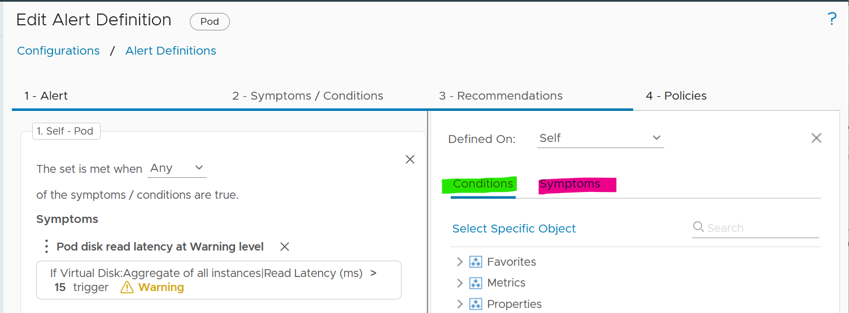

Recommendation | Remediation
Recommendation is just a piece of advice. It does not have ability to change. Remediation, on the other hand, will execute change in your environment. Recommendation is safer as it’s not automated.
It’s hard to develop a great remediation, or complete-yet-concise recommendation. The reason is the root cause is typically far from the alert triggered. There are too many combinations. We need to stop thinking that IT products have good observability. IT systems actually have poor visibility into what happened. Can you troubleshoot when your web browser is slow even though your high-end laptop is fast and overall utilization is low?
No, you can’t. If you can’t troubleshoot a single PC, why do you expect we can troubleshoot something far more complex? Observability is always a second-class citizen in product development. Most products only have few meaningful metrics. Even if they do have the metrics, they don’t provide API. Even if they have, the metrics could be unreliable or buggy.
A good recommendation is clear. It needs to list its assumptions and explain the reason behind the recommendations.
In the ideal world, your alerts are fully automated. The problem is RCA today is largely an exercise of elimination. It is a process that requires human expertise on the architecture. For example, to troubleshoot Tanzu, you need to know K8 + vSphere + Tanzu specific implementation.
The reason why we have to resort to elimination exercise is the lower layer or stack does not carry information from upper stack. For example, ESXi SCSI commands can’t be traced to specific VM.
Maybe one day we can have AI-assisted troubleshooting. I envisage the human expert “records” the steps. This becomes the training dataset.

Application Team
We start with Guest OS as this is the closest layer to the application. This alert is for someone responsible for the application, running on top of Windows or Linux. It is not relevant to the infrastructure team.

Guest OS Alerts
Since performance problem can happen within Guest OS, independently of virtualization, you need to monitor within this layer. The goal is to proactively manage performance before business is affected. The challenge happens when there is no application level or user transaction level monitoring. Another word, the application team simply rely on complaint. The problem with complaint is it’s highly subjective. The correlation to technical counters is both weak and unpredictable.

CPU Contention
Goal | The CPU Run Queue is relatively less known due to the focus on CPU Utilization.  This alert is likely independent of the underlying virtualization layer due to the nature of some applications which spawn excessive threads.  Demonstrate to application team or VM owner that the IaaS team has visibility into Windows or Linux.
Red Condition | All these conditions must be met for 15 minutes:  - Guest OS Peak CPU Queue > 20  - VM Net Run > 75%
Orange Condition | This is not provided to reduce noise. If you need to set, follow these:  - Guest OS Peak CPU Queue > 10  - VM Net Run > 75%
Design Consideration | As the CPU Queue counter is known to have false positives, we increase the wait cycle to 15 minutes, and add Net Run to ensure it only happens when there is sufficiently high workload.
Design Consideration | The alert works together with the VM CPU Utilization alert and VM CPU Contention alert. Use these 3 alerts together.
Remediation | If the alert of high VM CPU contention is also triggered, then follow the remediation for this alert.
Remediation | If the alert of high VM CPU consumption is also triggered, then follow the remediation for this alert.
Remediation | If the above 2 are false, look at the application on why it’s creating many threads. Compare the values with other software or code that are part of the larger business applications. Also, compare the value with the same software in other business applications. If the software is a commercial software from IT vendor, ask the vendor for their recommendation as the maker of that product.  If you do not get the answer, exclude this application from this alert.

Disk Contention Alert
Red Condition | All these conditions must be met for 5 minutes:  - 20-second peak disk queue > 10000  - CPU Usage > 1 GHz
Orange Condition | All these conditions must be met for 5 minutes:  - 20-second peak disk queue > 5000  - CPU Usage > 1 GHz
Design Consideration | There is no official guidance from either operating system. This alert is set at relatively high number, so adjust as you deem appropriate
Design Consideration | If you have excessive false positive, disable the orange condition.

Other Contention Alerts
What other performance problems can exist only within the Guest OS, which is not caused by underlying virtualization? There are many possibilities. I’m not creating alerts as their threshold vary wildly by applications.
You should create your own alerts for the following:
- Check if CPU Context Switch is consistently high. Inform developers that this could cause application performance problem. If the VM CPU Net Run is low, and run queue is low, then reduced the vCPU size.
- Heavy memory paging, coupled with high amount of page fault.
- High number of outstanding disk operations.
- Network dropped packet. Note this requires Telegraf agent.

Consumption
There is no alert defined, as it could result in false positive.
There are, however, proactive check you can do:
- Check CPU Usage Disparity. If it’s consistently high, discuss with VM Owner on why application unable to use all vCPU equally. Reduce size if not required, especially if CPU Context Switch is high and run queue is low.
- Check free memory. If it’s consistently near 0 MB, coupled with moderate or high amount of paging, discuss with VM Owner if this impacts performance. Do application-level benchmarking before and after as too much memory can negate performance.
- Low disk space. Not yet implemented as certain partitions such as swap is always near 100%. This cannot be implemented at VM virtual disk layer.

VM Alerts
In overcommit environment, a VM can experience contention. How do you balance between application team catching this alert, and infrastructure team to address the issue first?
The balancing will minimize blamestorming. Some techniques:
- Avoid using the orange alert. So it’s only red. You keep the orange for the infrastructure team, so they have a heads up.
- Use a higher threshold. For example, you set CPU Ready > 8% for application team and > 6% for infrastructure team.
Alert at infrastructure level, such as ESXi, is not relevant.

CPU Alerts
Design the CPU alerts as a set. That means cover all objects, and for each object, cover both contention and consumption. The contention alert and utilization alert should be used together. Especially for consumer, where capacity can be increased at a moment notice, increasing capacity when there is contention will result in inferior performance.

Contention Alerts
VM and IaaS have different perspective. For the shared infrastructure, the alert should focus on population issue, as opposed to just a small subset of VMs. We use 25% of VM population as the overall threshold. As this can mean hundreds of VM, we choose a lower threshold per VM.
This means ESXi, Resource Pool and Cluster. Data Center is not added as it can consists of clusters of different purposes.

VM Contention
Red Condition | All these conditions must be met:  - Peak vCPU Ready > 32%  - CPU Ready > 8%  - CPU Contention > 8%  - CPU Usage > 1 GHz
Orange Condition | All these conditions must be met:  - Peak vCPU Ready > 32%  - CPU Ready > 4%  - CPU Contention > 8%  - CPU Usage > 1 GHz
Design Consideration | An absolute unit is used for CPU utilization as opposed to relative (%) as a small percentage of a monster VM could still be sizable
Remediation | This is complex. See the diagram at the start of CPU Alert section.

Infrastructure Contention
Red Condition | All these conditions must be met:  - Peak vCPU Ready > 24%  - CPU Contention > 6%
Orange Condition | All these conditions must be met:  - Peak vCPU Ready > 12%  - CPU Contention > 3%
Design Consideration | For cluster, we measure directly at VM level so it’s closer to what we care, which is the application. Aggregating from ESXi is less accurate.
Design Consideration | For resource pool, the symptom does not work with cascading RP. Stacking RP on top of RP complicates operations.
Remediation | This is complex. See the diagram at the start of CPU Alert section.

Consumption Alerts
Utilization alert is tricky to define as high utilization could mean good or bad.

VM Consumption
Goal | High utilization could cause business performance, especially for online workload where end users expect a “real time” response time.
Red Condition | All these conditions must be met for 15 minutes:  - VM CPU Net Run > 95%  - Guest OS CPU Queue > 4
Orange Condition | There is no orange alert as it will create more false positives.
Design Consideration | 15 minutes is used instead of 5 to reduce false positive. Take note this means you will lose 15 minutes.
Design Consideration | Added Guest OS CPU Queue to ensure that there is actual bottleneck, as opposed to running optimally. This should result in a more meaningful alert.
Remediation | Find out the nature of the application. If it’s batch job, the CPU Net Run could be sustaining at >95% for the entire duration of the batch run. So long the job is completed within the expected window, this is a healthy behaviour. Exclude this application from this alert.
Remediation | Find out from application team what metrics at application-layer or business transaction layer are proving that there is queue and latency. If the pattern matches the number at the infrastructure layer, then add vCPU.  In the event you decide to add CPU, make sure it’s NUMA compliant.

Infrastructure Consumption
Red Condition | All these conditions must be met for 10 minutes:  - CPU Thread Utilization > 40%  - CPU Core Utilization > 80%
Orange Condition | There is no orange alert as it will create more false positives.
Design Consideration | As this is a provider, the focus is on capacity management, not performance. Space, not speed. That’s why counter such as Usage is not used.
Design Consideration | The threshold is not that high as we need to consider HA. Ideally, we should add the HA buffer into the threshold dynamically.  If this results in excessive noise, increase the threshold to 50% and 100%.
Design Consideration | It is not set for Resource Pool as its use case varies.
Design Consideration | For cluster, it’s simply based on > 25% of ESXi members of the cluster

Memory Alerts
Design the memory alerts as a set. That means cover all objects, and for each object, cover both contention and consumption.

Contention Alerts
Memory performance is hard to trace. The memory contention can be come from different factors. We can’t distinguish how much each part contributes. For example, VM 001 has 51% memory contention. This could be due to:
- 5 MB was limited Limit.
- 1 MB was swapped.
- 2 MB was compressed.
- Low shares setting played a part.

VM Contention
Red Condition | All these conditions must be met:  - Peak Memory Contention > 24%  - Memory Contention > 6%  - CPU Usage > 1 GHz
Orange Condition | All these conditions must be met:  - Peak Memory Contention > 12%  - Memory Contention > 3%  - CPU Usage > 1 GHz
Design Consideration | An absolute unit is used for CPU utilization as opposed to relative (%) as a small percentage of a monster VM could still be sizable

Infrastructure Contention
Red Condition | All these conditions must be met:  - Peak Memory Contention > 16%  - Memory Contention > 4%
Orange Condition | All these conditions must be met:  - Peak Memory Contention > 8%  - Memory Contention > 2%
Design Consideration | For cluster, we measure directly at VM level so it’s closer to what we care, which is the application. Aggregating from ESXi is less accurate.
Design Consideration | For resource pool, the symptom does not work with cascading RP. Stacking RP on top of RP complicates operations.

Consumption Alerts
There is no alert set at VM level as VM is just a motherboard.
There is no alert set at Guest OS level as it varies per application.

Infrastructure Consumption
Red Condition | All these conditions must be met:  - Balloon > 10 MB AND  - Consumed > 95%
Orange Condition | There is no orange alert as it will create more false positives.
Design Consideration | 10 minutes is used instead of 5 to reduce false positive. Take note this means you get notified later.
Design Consideration | Balloon is set in an absolute term (10 MB) and not relative to the ESXi memory consumed so the impact is standardized.
Design Consideration | Swap and Compressed are not included so that alerts are triggered earlier, as remediation action, such as reducing demand, can take hours or days to complete.
Design Consideration | It’s set at 50% of host members as clusters are mostly <20 hosts, and memory functions as cache (so more does not mean it’s slow)

Storage Alerts
Design the storage alerts as a set. That means cover all objects, and for each object, cover both contention and consumption.

Contention Alerts
Read latency and write latency are separated as their causes are typically different. The remediation actions likely differ as a result.

VM Contention
Red Condition | For read latency, all these conditions must be met:  - Average Read Latency > 80 ms  - Peak Read-or-Write Latency > 320 ms  - CPU Usage > 1 GHz  - Disk Read IOPS > 100
Red Condition | For write latency, all these conditions must be met:  - Average Write Latency > 80 ms  - Peak Read-or-Write Latency > 320 ms  - CPU Usage > 1 GHz  - Disk Write IOPS > 100
Orange Condition | For read latency, all these conditions must be met:  - Average Read Latency > 40 ms  - Peak Read-or-Write Latency > 160 ms  - CPU Usage > 1 GHz  - Disk Read IOPS > 100
Orange Condition | For write latency, all these conditions must be met:  - Average Write Latency > 40 ms  - Peak Read-or-Write Latency > 160 ms  - CPU Usage > 1 GHz  - Disk Write IOPS > 100
Design Consideration | Due to difference between vendor best practice and reality in customer environment, we set the wait cycle to 10 minutes and increase the threshold. In theory I agree we should pick a lower number, but in reality, there is hardly any complaint. Try to convince your boss to invest when there is no complaint 😉
Design Consideration | The 20-second peak cover both read and write. Yes, this is a known limitation.
Design Consideration | CPU Usage and Disk IOPS are added to reduce the alerts during low activity. The idea is business impact could be negligible during low disk activity.

Infrastructure Contention
Not yet implemented. The reason is the many:many relationship between VM and datastore makes it impossible for us to set condition at VM level.
If you create, use these as a guide:
>25% of VM population has latency > 10 ms AND highest VM latency > 40 ms AND Overall Datastore Latency > 5 ms.

Consumption Alerts
Storage consumption covers both capacity (disk space) and performance (IOPS and throughput). Performance is hard to quantify due to the lack of “100%”. The ceiling is hard to define.

Object | Threshold for Red level
Datastore | Used space > 90%.
Datastore Cluster | Not yet implemented. It needs to trigger when a member datastore has > 90% used. The remediation is to trigger storage DRS.

Network Alerts
Consumption alert is hard to quantify due to the lack of “100%”. The ceiling is hard to define.

Contention Alerts
Object | Threshold for Red level
VM | Transmitted packet drop > 4% and
VM | In future the threshold should be relative to packets transmitted. 4% is a high threshold as that means 1 in 40 packets were dropped. However, since it happens within a 20-second period, it is set high.
VM | Orange alert is not set to minimize alert storm. Dropped packets are typically retransmitted, so users do not experience problem. So the ratio is always 100%.
ESXi | Transmitted packet drop > 50 packets for virtual network
ESXi | Transmitted packet drop > 50 packets for physical network
Distributed Port Group | Red alert: Dropped packet > 10%  Orange alert is not implemented due to false positive. In future I will change to transmit only.
Distributed Switch | Likely not applicable, as it’s just a group of ESXi and port groups.

Overall Design Approach

Design Consideration
To a few of us who love visualizing information with VCF Operations, we see the dashboard as a canvas. Granted, the widgets have limitation but that’s part of the art 😊
Creating dashboards is an art as you need to balance many conflicting requirements, such as:
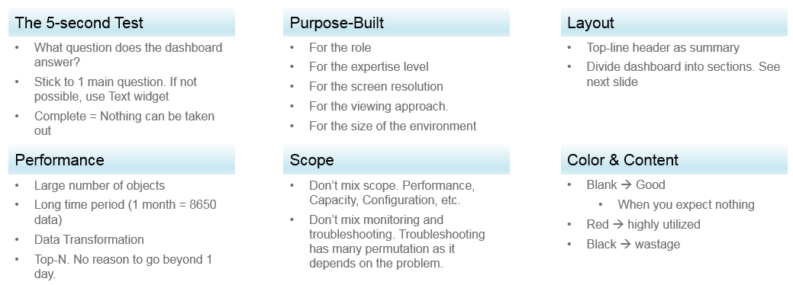
Can the dashboard be understood within 5 seconds? If yes, you buy yourself a few more minutes. The user understands what the dashboard does, and is willing to spend more time mastering it. To pass this test, think of which information, object, metric can you take away from the dashboard? See the KISS Principle, because an uber-dashboard that tries to please everyone and cover all scenarios will end up not being used.
Begin with the end in mind. The purpose dictates the dashboard design. 2 dashboards can have an identical target role, purpose, and use case (e.g. performance), but if the size of the environment differs, the 2 dashboards will be different. An environment with 50,000 VMs is managed differently with an environment of 500 VMs.
A good dashboard answers a set of questions. So jot down the questions. Be specific, including the metric and how it needs to be visualized.
A small environment with 100 VMs in just 8 hosts in 1 cluster (hence 1 data center, 1 vCenter) needs less dashboards than an environment with 10,000 VM spread over 800 ESXi hosts, 100 clusters, 10 data centers and 3 vCenter Servers.
Product wise, the dashboard feature in VCF Operations complement its built-in pages. Each page is hand coded HTML with precision. For customers who need to customize and personalize the information, we’ve provided out of the box dashboards that complement the existing page.

Design Methodology
This section introduces us to a few considerations surrounding dashboard design. We will walk through a method where we are able to understand the user, the activity, the workflow and the other aspects needed to understand the context before we start.
When we create dashboards that are used by others in our team we have to consider a few aspects that are helpful in making information useful, usable and delightful.

Who | Begin with the end in mind. Who are actually using the dashboards you create? What specific role and persona is going to use it?  Start by creating a list of all users who would be accessing and using information in the dashboard  Against this list mention the kind of information they would find useful for the specific persona.
What | What is the type of activity (granular vs. high level) they will perform?  List next to the task if the information needs to be granular or high level. Sometimes users are looking for just a KPI number, sometimes they are looking for trends. Sometimes users might want to interact with the information, create drill downs etc.  The complexity of the activity will help you identify if you need a complex widget or a simple one.
How | How (workflow) will they use the dashboard?  List down what happens after they view the information, do they need to use another application, another visualization. Plan accordingly and place navigation to enable this to happen.
When | How often (hourly, daily, weekly, monthly, quarterly) will they use the dashboard?  Think about the usage of the dashboard, is it a frequent use case needed for daily use to perform work, or is it for monitoring on an irregular basis.
Why | Why (outcome) do they need the dashboard?  Also list down outcomes from the dashboard usage. What is the usefulness of using the dashboard and what goals or outcomes the user is likely to achieve.

Once we get this information we can better design dashboards based on the needs of the users. One way could be to plot it on a grid to understand the impact better. Let’s start with a grid like this one.
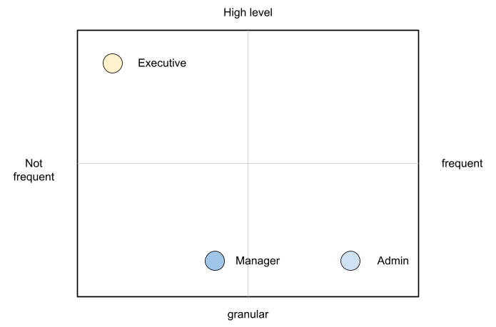
An executive might use the dashboard less frequently and the type of tasks they would perform could be high level. If you make a dashboard that is very granular and requires a lot of effort the executive might not have the time to use the dashboard.
A manager might use the dashboard once a week, or on a monthly timeline, might need information on both granular or high-level.
Similarly an admin agent might use it on a daily basis and might need information at times that needs a lot of effort and at other times just a metric number would do.
Once you have reached a visualisation like this, you can better judge. If it needs to be a single dashboard or multiple based on the persona. What items should you prioritise and what kind of complexity is necessary based on the timeframe and time available with the stakeholder

Clean Layout
Divide the screen into sections visually. This makes the dashboard easier to read. Here are some examples of how you can divide the screen.
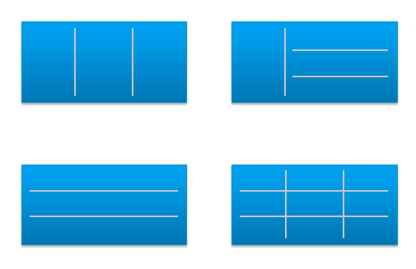

Example 1
Here is a good example of layout from Brock Peterson. Notice how simple it is. It is clear that it has 4 layers as layout is consistent among them.
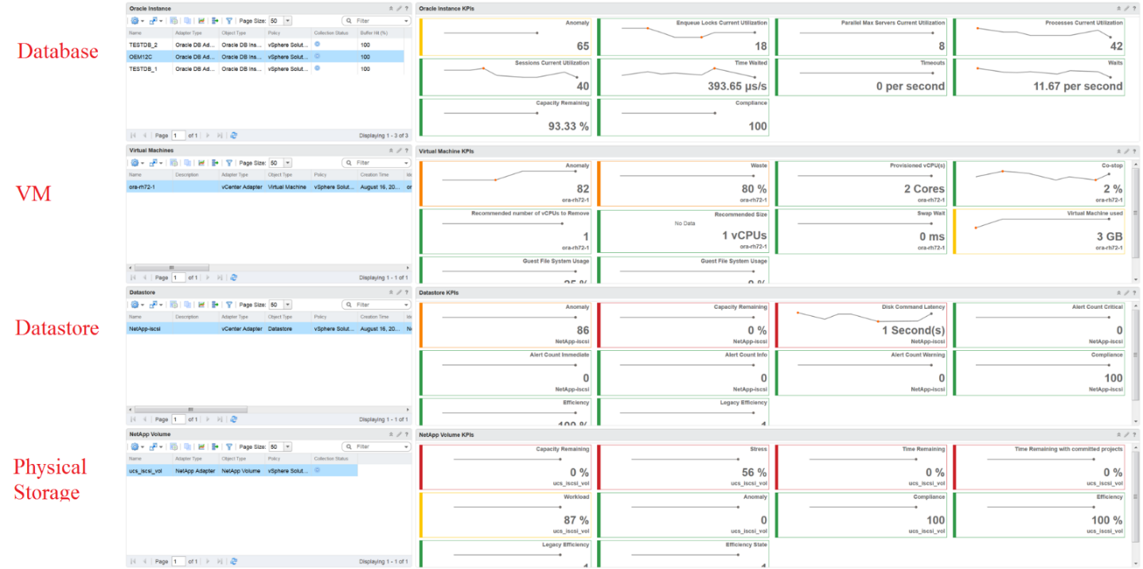

Example 2
You should also play with Dark Mode, and see how that looks. The following shows a clean layout in dark mode. Notice how Dale Hassinger has arranged this dashboard well.
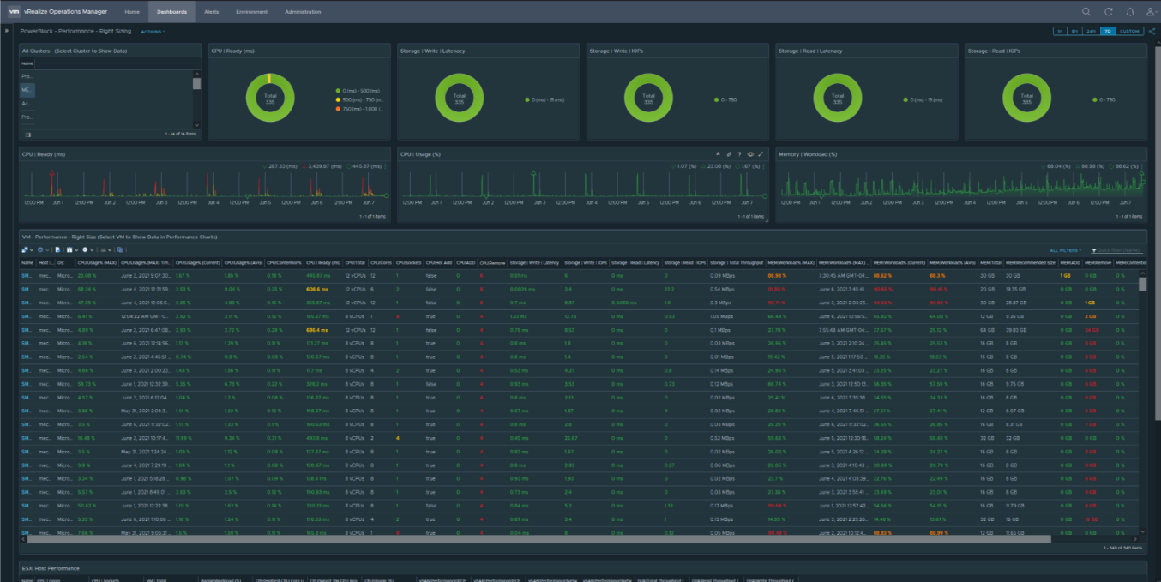
Visually, he has designed the layout “top down”, making it easier to see.
Another technique is to create 2 sections: summary and detail.
- The summary section is typically placed at the top of the dashboard. It gives the big picture.
- The detail section is placed below the summary section. It lets you drill down into a specific object. For example, if it’s a VM performance, you can get the detail performance of a specific VM.
This detail section is also designed with quick context switch, as you may want to check the performance of multiple objects during performance troubleshooting. Take for example VM performance. The dashboard gives you all the VM-specific information and allows you to see the KPIs without changing screens. You can move from one VM to another and view the details without opening multiple windows.

Color as Meaning
It’s easier to see color than read numbers, if the color has meaning. There are many occasions in operations that you just need to know if things are good or bad first, before diving into the actual raw value. Color is also easier at a glance, especially if you have read hundreds of numbers inside a large table.
Here is the color I recommend:

Green –> Yellow –> Orange –> Red | Green means good, and gradually getting worse as it moves toward red.  Typically used in performance monitoring and compliance.  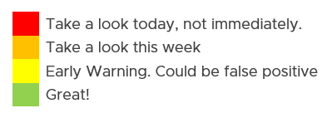
Dark Grey –> Green … Red | We use dark grey in Capacity as wastage (unused) is a bigger issue than over utilization. It’s important to show wastage as it can also impact performance.  For performance dashboard, you should consider using red to convey that oversized is bad for performance.
Blue | Neutral color. Used when it does not have any meaning.
Grey | System error. The data is missing due to collection error.  Typically happens in heat map. We use a color instead of white as white is hard to read.

Threshold
At which point do you change the color? This is where threshold comes in.
Try to make the scale easy to remember by adopting a consistent scale
- Yellow = 2x Green
- Orange = 2x Yellow
- Red = 2x Orange
The above also results in red being 8x green.
The above does not work when the scale is small. For example, in Horizon, a user typically has 1 – 4 desktops. It’s rare for users to go beyond that. So in this case, your threshold is as follow:
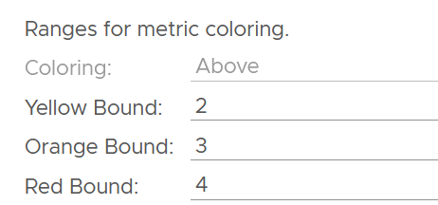

Gradient
Gradient can be handy in widget where relative comparison among many objects is important. In the following example, the widget is answering the question about the severity of imbalance among vSAN disk groups. What’s your conclusion if you solely rely on the color?
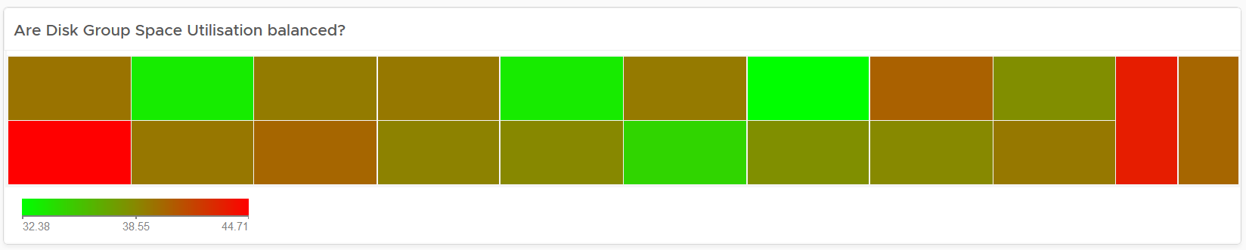
Oh no, they are not balanced. Let’s initiate rebalancing, which can potentially move Terabytes of data!
But wait! We only care about unbalanced when they are significant. Minor unbalance is expected. In fact, if they are perfectly identical, it would be strange.
The problem with the above widget is utilization should only turn red when it reaches 75%.
After fixing the 2 preceding problems, we have a meaningful heat map.
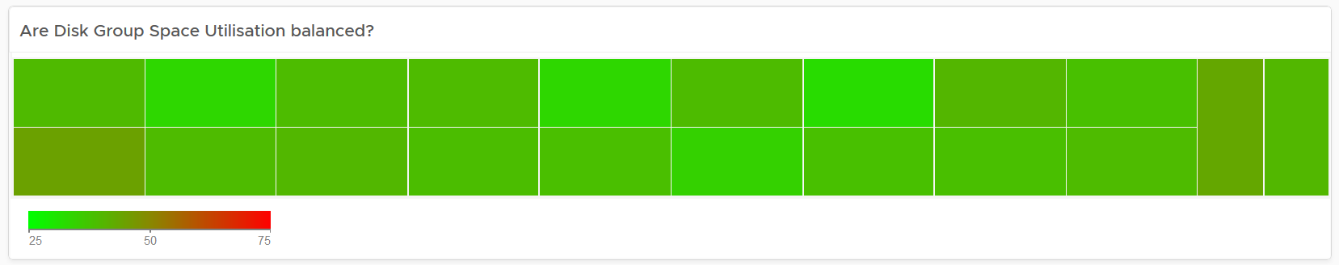

Example Implementation
In the Compliance dashboard below, color is used to quickly show the various level of compliance. If all you see is Green, there is no need to look at the numbers & texts!
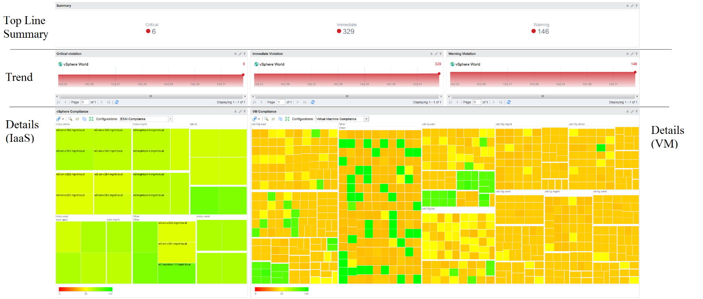
Last but not least, think of users who may not be able to distinguish all the colors. Provide alternative way for them so the functionality is not lost.

Past vs Present
Think of what timeline you need to show, as there are use case for both the present and the past. The past useful when the present data does not tell the full picture as it depends on the time you login and see it. If you login at 8 am in the morning to see what’s happening over night, then the value at 8:00 am is not answering your question.
The past is harder to visualize as it has >1 data points. Ideally, you show the data as a line chart so you can see the trend. Showing a single data such as the maximum or average can miss critical information such as “is it trending upwards or downwards” and “how long did the peak last?”. The problem with line chart is it takes up screen real estate.
If you need to show a lot of objects or metrics, then you need to summarize. As covered in Leading Indicator, you may need to show 2 numbers, especially if one of them is an average.

Summary List Detail
In large environment, you manage a large number of items (e.g. K8 pods, AWS EC2). This means you need a way to summarize the information, so you can work with a subset of the group. Within this subset, you need to know which particular item to work on.
The flow Summary List Detail is one common technique to achieve the above.

Summary
The summary shows the overall picture, not a subset.
There are 2 techniques of visualizing:
- Number oriented. Useful when the absolute value matters.
- Non number oriented. Useful when relative values of the numbers matter, as the numbers form a set.
The number-oriented uses a scoreboard. I find scoreboard is a good way to start, especially if the numbers are suitable for color coding.
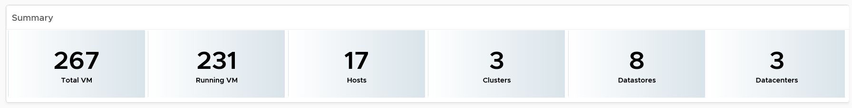
Based on the scoreboard, you may want to drill down to a subset of the environment. Take note that the drill down is based on the object owning the metric.
The non number oriented uses a distribution chart, such as bar chart or pie chart.
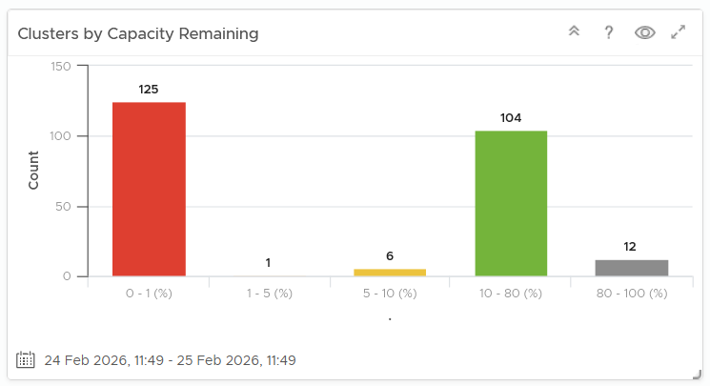

List
The View List widget is a table that lists all the objects. Use a filter if the number of items is large.
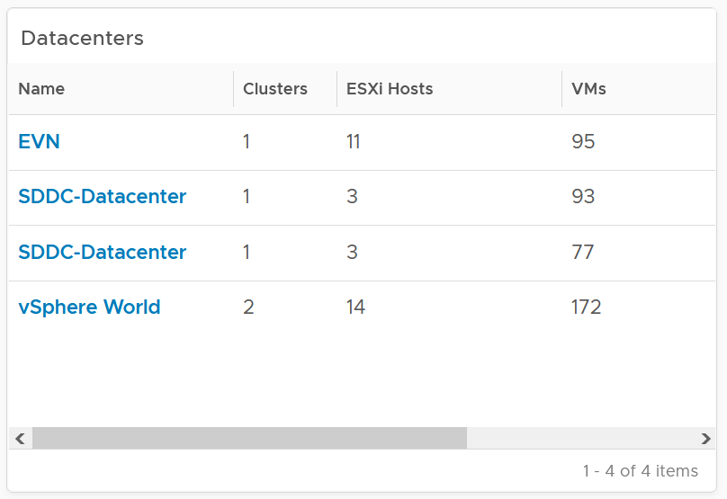
Having a filter also helps the dashboards scalability as showing tens of thousands of objects will impact the dashboard performance. It also improves usability as you can use progressive disclosure, and draw user attention to the big picture first.

Detail
At the detail level, you deal with a single item, such as a Horizon session. If the item has large numbers of metrics to show, you need a way to see them before plotting the trend chart. I found the Scoreboard the most suitable as it can be color coded and supports drills down to see the trend chart.

Interaction
Interaction allows you to build interaction within the widgets. So it is intra-dashboard, while navigation is inter-dashboard. Take advantage of the interaction & navigation, but keep them consistent so they are not too complex.
Logically design the dashboard first using any drawing tools so you can see the flow of information. I typically use PowerPoint, as shown in the following example.
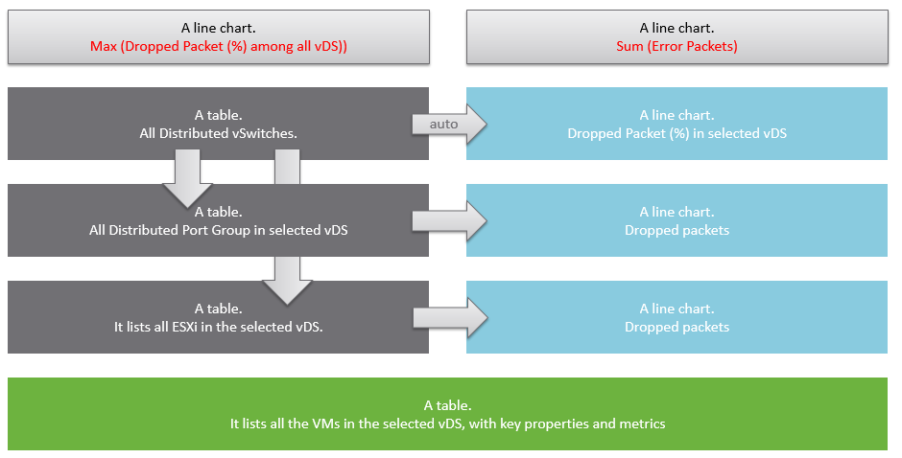
A rich interaction will increase the functionality of the dashboard. Aim for a symmetrical interaction as it’s easier for the dashboard consumer to understand. The following shows 4 heat maps driving 4 line charts in a 4x4 combination. It looks complicated in the screenshot below but feels natural when actually used.
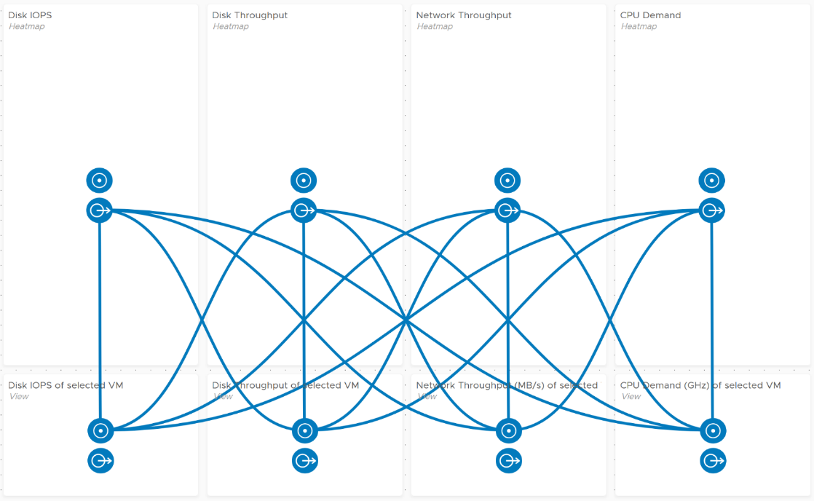
Use progressive disclosure to minimize information overload and ensure the webpage loads fast. On the other hand, so long your browser session remains, it remembers your last selection.

Overall Design: Inventory Dashboards
The suite of dashboard works together as one integrated set. They also have similar design.

Goals | Check if the inventory matches your expectation. Not just the count but also the change.
Goals | Cover all objects in VCF where inventory matters.
Questions | What VMs do I have? Where are they located? What’s the changes I need to know?
Assumptions | To be used with configuration dashboards
Target Users | Platform Team
Usage frequency | Mostly ad hoc, on a need basis  Daily for VM inventory changes.
Features | Visual relationship of objects.
Features | Ability to traverse the inventory hierarchy quickly
Features | Show the hierarchy and count of objects in the hierarchy. Ideally, it shows the movement of the inventory.

Overall Design: Performance Dashboards
The suite of dashboards works together as one integrated set. They also have similar design.

Goals | Monitor performance
Goals | Troubleshoot performance
Questions | Examples of questions answered by the dashboards:
Questions | Are the VMs performing well? If not, which pods are affected by what problems (CPU, Disk, RAM, Network)?
Questions | Is the VM performance caused by IaaS not serving it, or by contention within the Guest OS?
Questions | Are the VMs running high utilization? If yes, which VMs, how high, and what resource (CPU, RAM, Disk, Network)?
Questions | Are they really high relative to the underlying IaaS capacity? That can cause strain in the shared infrastructure.
Assumptions | They are designed for both day-to-day operations (proactive monitoring), and ad-hoc reactive troubleshooting. As a result, it’s an advanced dashboard, not designed for Level 1 Support.
Target Users | VMware Administrators or Architects
Usage frequency | Daily for monitoring. This is to encourage daily usage, as what happens beyond 24 hours ago may be practically irrelevant from performance troubleshooting viewpoint. Hence the views are set to show data in the last 8 - 24 hours.
Usage frequency | Ad hoc for troubleshooting. Designed to be used within the day of the performance issue, or at most the next day.
Features | Color coded. Each of the color is according to the best practice of that counter.  If you are unsure of what suitable numbers to set for your environment, profile the metrics. The Guest OS Performance Profiling dashboard provides an example of how to profile metrics. We also document the steps in Baseline Profiling section of the book.
Features | Design to see trend over time, and go back to any point in time. This is important as by the time you have the chance to look at the problem, 5 minutes have passed, or the problem is no longer happening
There are 2 types of performance troubleshooting
- Consumer. You focus on a single VM, container or application. Other consumers do not have a problem, or they are independent.
- Provider. You focus on the shared infrastructure as the problems impact many consumers. It could be hitting them at random, meaning different VMs/Applications got hit at different time.
At the infrastructure layer, we care whether it serves everyone well. Make sure that there is no contention for resource among all the VMs in the platform. Only when the infrastructure is clear from contention can we troubleshoot a particular VM. If the infrastructure is having a hard time serving majority of the VMs, there is no point troubleshooting a particular VM. Notice all the previous sentences are about the VM. Yes, the infrastructure metrics are not that relevant.
Logically split the dashboard into 3 parts:

Contention | This should be the first part, and most visible.
Consumption | Once you determine there is contention, use the Utilization portion to see if the contention is caused by very high utilization. When utilization exceeds 100%, performance can be negatively impacted especially when queue developed inside the Windows or Linux.  By default, VCF Operations has a 5-minute collection interval. For 5 minutes, there may be 300 seconds worth of data points. If a spike is experienced for a few seconds, it may not be visible if the remaining of the 300 seconds is low utilization.
Configuration | Only include the relevant settings that can impact performance
This separation keeps each dashboard simple, while emphasizing the concept of contention as the primary counter for performance. You will notice in the dashboard design that contention is color coded, while utilization is not.
Take note that health chart is not ideal when the metrics do not have a “ceiling”, meaning we don’t know what “high value” is, as 100% is hard to define. Example of such metrics are disk IOPS and CPU context switch. If your operations team has a standard that utilization should not exceed a certain threshold, you can add that threshold value into the line chart. The threshold line will help less technical teams as they can see how the real value compares with the threshold.
For large vSphere environment, group the VM by clusters of the same class of service (e.g. Gold), so you can see the profile for each environment. I find the Data Center as good boundary. In general, storage, network and compute do not extend beyond a vSphere Data Center object. Performance problems tend to be isolated in a single physical environment, unless the WAN link connecting the 2 data centers are causing the problem. A performance problem in country A typically does not cause performance problem in country B, especially if they share little in common.
The dashboards share the same design principles, hence they are intentionally designed to be similar. It will be confusing if each dashboard looks totally different from one another, considering they have the same objective. To avoid repeating the explanation, read the VM Performance dashboard before reviewing others.

Overall Design: Capacity Dashboard
You may notice that the performance dashboards and the capacity dashboards share similar layout. The reason is there is commonality in both pillars of operations.
The suite of dashboards work together as one integrated set. They also have similar design.

Goals | Determine overall capacity. Cover compute, storage and network.  Network covers ESXi physical NIC, NSX Edge and NSX Manager.
Goals | Optimize capacity. Reclaim, rightsize, and redistribute.
Questions | Examples of questions answered by the dashboards:
Questions | What’s the overall capacity? Do we have enough CPU, memory, disk and network to meet present demand + demand in the near future?
Questions | Any hot spot? Do we need to rebalance?
Questions | How severe is the wastage? How much can we easily claim within a month? How much will take much longer to reclaim?
Assumptions | Users will use the built-in pages. These dashboards are designed to complement, not replace.
Target Users | Capacity Team.  This is the main target. The team responsible for overall capacity life cycle, from planning to upgrade. Not interested in day to day, such as a host goes down or put into maintenance. Keen on long term and top down view, as they are planning future expansion and ageing hardware technological refresh.  Their primary focus is the Provider
Target Users | Operations Team.  The team running the day to day, live operations. Not interested in long term, both the past and the future.  Their primary focus is the Consumer, especially oversized VM.
Target Users | Storage Team.  Specialist team. Collaboration become critical if the architecture is “thin on thin”.
Usage frequency | Weekly
Usage frequency | Quarterly
Features | The dashboard is designed “top down”. It has 2 sections: summary and detail.  The summary lets you see the big picture.  The detail section is placed below the summary section. It lets you drill down into a specific object. For example, if it’s a VM capacity, you can get the detail capacity of a specific VM.
Features | Quick context switch. You can cycle through objects quickly without changing screens or opening multiple browser windows.
Features | UI wise, the dashboard uses progressive disclosure to minimize information overload and ensure the webpage loads fast. On the other hand, so long your browser session remains, it remembers your last selection
Features | Color coded.  A high capacity remaining could indicate wastage. For ease of identifying, wastage is shown by a new color. Dark grey indicates wastage as capacity is not used. In fact, there can be performance problem is the low utilization was caused by bottleneck somewhere else
Features | Complement the out of the box pages by visualizing information differently and giving more choice of customization. For examples, the reclamation size is grouped into buckets so you can focus on the largest reclamation opportunities first, and trend charts are provided so you can quickly see the growth over time, without changing context (e.g. open a new screen).
There are 2 types of capacity management
- Consumer. You focus on a single VM, container or application. You want to right size them and reclaim unused portion.
- Provider. You focus on the shared infrastructure as the problems impact many consumers.
For cluster, special types of cluster alter the capacity model. One example is stretched cluster. It needs its own capacity model and visualization. You will need to have an object or custom group for each site, and then displays them side by side.

Overall Design: Configuration Dashboard
Use the Configuration dashboards to view the key configuration in your VCF environment, especially for areas that need attention.
The suite of dashboards works together as one integrated set. They also have similar design.

Goals | Address configuration issues before they cause impact
Goals | In the event of issues, check configuration to see if it plays a part.
Questions | Are the configuration matching best practices?
Questions | Are the settings consistent when they have and up to date as per our plan?
Questions | Do we have undesirable drifts?
Assumptions | You have the enterprise standard and policy documented.
Target Users | Platform Team
Usage frequency | Daily, for urgent settings
Usage frequency | Weekly, for non-urgent settings.
Features | Show the configuration that needs attention first, before showing overall configuration. The idea is to drive action towards optimizing configuration.
Features | Balance ease of use, performance (loading time of the dashboard page) and completeness of configuration check. As a result, you may not be able to show all settings of desired objects. Lack of screen real estate is another consideration behind the design
The current dashboards are:

VM Configuration | These 2 dashboards work together. The 2nd dashboard is created as the dashboard was simply too large, impacting usability.
VM Storage Configuration
ESXi Configuration | These 2 dashboards work together. The 2nd one is prefixed with vSphere as the word cluster is a generic English word.  Ideally, there is a drill down from cluster dashboard to ESXi. However, that will increase complexity in the user interface.
vSphere Cluster Configuration
vSphere Resource Management | This needs to be a separate dashboard as the configuration spans VM, resource pool and clusters. The flexibility and complexity warrant a dedicated dashboard to help you optimize.
vSphere Network Configuration | These are basic dashboards. In future, I’d enhance them.
vSAN Configuration | These are basic dashboards. In future, I’d enhance them.
In some dashboards, there are simply too many configuration items to check than the screen real estate provides. If you have a larger screen, add the additional check as you deem fit, or add legends to the pie-charts.
In a large environment, create a filter for this dashboard. Group by the class of services such as, Gold, silver, and bronze. Default the selection to Gold. In this way, your monitoring is not cluttered with less critical workloads.

Overall Design: IT Leaders Dashboard
The most important persona or role is your boss. In large organisation, there can be multiple layers between you and your CIO. Each layer has their own needs. Understand the need of each individual. The nuance matters. Different managers are likely having slightly different requirements. Take time to understand the real needs behind the ask. Learn what questions need to be answered, what answers are expected, and what actions are taken based on the answer.
You also need to think of what you want from them, as they hold decision making authority. Show them problems that you can get help, which is budget and resource. Do this by showing data. By giving visibility into live environment to senior management, you prove that you do need additional hardware. If there is wastage to be reclaim, you also prove on where and how large the wastage is.
Think of what approval you need to do so you can do your work. How do you present the supporting information without burdening them with too many details?

General Requirements
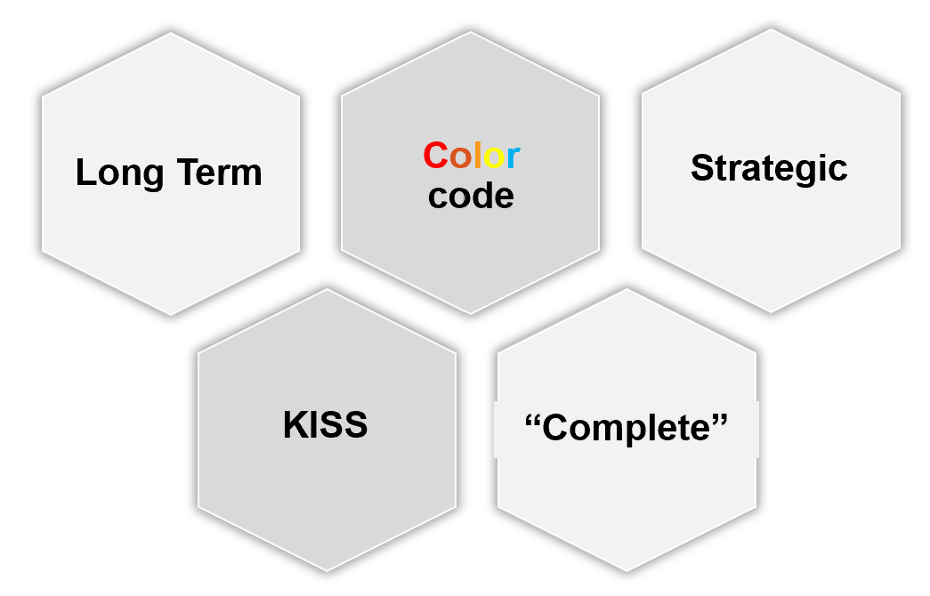

Summary | Generally, they want summary and the big picture, not details. Or at the very least, the big picture is presented first, and then drill down is provided.
Summary | As part of showing the big picture, trend should be included. Show the situation in the last few months, ideally coupled with projection. The data should be averaged out, so that a 5-minute spike should not show up.
Summary | Exception. Things that they need their attention. Complete means nothing else can be taken out. Which information, object, metric can you take out while preserving the point?
Offline | They prefer information to be emailed so they can access from anywhere easily. They may not want to login to VCF Operations.
Offline | They appreciate offline access as they tend to be mobile. Some may even ask for the information to fit on a mobile phone screen, or just a single screenshot. For off-line access, verify the screen size. A small screen of 7” can only display a small subset than say a 14” display.
KISS | KISS. Keep it simple solution. Keep the interaction, clicking, zooming, sorting, etc. minimal. Use larger fonts, round numbers (law of significant figure).
KISS | UI that is easy to understand. So keep each dashboard to a specific question. Make sure the dashboard is easy to use. So keep the interaction, clicking, zooming, sorting, etc. minimal.
KISS | Can the dashboard be understood within 5 seconds?  If yes, you buy yourself a few more minutes. Your IT Management has understood what the dashboard does, and is willing to spend more time appreciating its full capabilities.
KISS | No technical info. Ideally, present in business terms, not IT jargons. Terminology such as datastore, distributed switch may need to be replaced with something suitable in your organization.
KISS | Take note of the “size” of your dashboard. A dashboard that has many widgets and scrolls deep is harder to understand.

If they ask for a self-service portal, then make it easy to access. They may not want to login to VCF Operations. If they do, they may forget their password, so the portal should not require a password.

Sample Requirements Analysis
The following table provides an example analyzis of 2 different IT leadership layers. Notice the 2 groups have a different set of requirements, resulting in 2 different approaches.

 | Middle IT Management | Senior IT Leadership Team
Users | John and Jill | Sam, Andy, and Julia
Users | They will read on their laptop. They have access to VCF Operations but only login occasionally in a week. | They expect a 15-minute presentation (live environment), with a copy of the PDF on their inbox for future reference.
Familiarity | High. They know the environment and context well | Low. They need explanation.
Focus | Keeping the lights on. | Last month review, especially compared against plan and SLA.  Finalize next month plan.
Focus | Availability, Performance, Security. | Capacity and Cost. How to lower cost while increasing capacity.
Authority | Medium-level changes. Budget up to ___. | Major IT decision that is strategic and long term.  Represent IT to Business Leaders
While you are clear on what they want from you, what do you want from them?
Having analyzed the requirements from each person, and from you to them, you develop the following approach:

 | Middle IT Management | Senior IT Leadership Team
On Mobile | Daily. First thing in the morning. Forward looking, not about the past.  A simple summary. Fits into 1 screen. | Weekly. On Monday. 1 week ahead outlook.  A simple summary. Fits into 1 screen.
On Desktop | Weekly.  2 pages. They will read all sections. | Monthly.  4 pages. They do not read all sections, as it will be presented to them. Done as part of overall operations review, which includes non VCF
Others | On demand login to dashboard. They can login and interact to get richer information. | You place a screen on the wall near their office. No interaction. It’s for at a glance look.

Business Applications
This is likely the most important, both from their viewpoint and your viewpoint. It proves that your infrastructure is playing its part well.
The report should provide a summary for all the mission critical business applications. As they are of the same level of importance, the list should be grouped by the business units.

Information | Description
Name | The business application name as per what the business or senior IT leaders call it. As business applications span multiple tiers, VM, and K8 Pod, you need to build the structure first in VCF Operations
Availability | Average uptime during the reporting period.  This shows Actual Availability (%), not Operational Availability (%) as the end customers (which are typically external or public) do not care about your scheduled downtime. Majority of websites has 24 x 7 x 365 days availability expectation, even if your customers are not global.
Performance | It shows their average performance over the reporting period.  As average can mask out poor performance at specific times, they may ask for worst number also.  If there are many business applications, they may ask for the average of all of them. They may ask for the information to be presented over time, like stock market performance.
Compliance | This is configuration compliant to both security and master template.
The above is one example. Another common example is infrastructure-centric report. As usual, understand the reason behind the ask. For example, they may not be familiar with the environment and inventory, and hence they ask for what you think is basic.

Operations Overview
This report summarizes what happened to VCF operations management.
- Was it a busy week or month? Were the operations hectic and environment volatile with a lot of debates?
- Was the environment well managed? Was the availability, performance, and compliance meeting the SLA?

Information | Description
Inventory | Summary of the key inventory items. This can be absolute or relative.
Inventory | Changes in the inventory. Was there a lot of items added or removed?
Inventory | Dynamics of the inventory. Was there a lot of settings changed?
Configuration | Summary or important configuration that either they care, or you want to bring up to their attention
Capacity | Is there enough capacity? If not, when should action be taken?  What was the change in capacity?
Performance | Ideally this is compared with SLA.

Sample Dashboards
VCF Operations provide two example dashboards to get you started. They are designed for you to present live information to your senior management. They are not designed as self-service.
This dashboard is used by the Ops team to provide the overall picture to the IT Management team. This dashboard works together with the set of inventory dashboards. The inventory provides details on available resources and what is running on these resources.
It also works with the capacity summary dashboard, which provides details on the resources remaining capacity and time remaining to act.

Capacity Summary
This dashboard is used by the Ops team to explain capacity to the IT Management team. It works together with the Inventory Summary dashboard. The inventory provides details on available resources and what is running on these resources. The capacity provides details on the remaining capacity and time.
See the Executive Summary Dashboards page for common design consideration among all the dashboards for IT senior management.

How to Use
The dashboard has 2 sections.
- The top section provides summary at the vSphere World level.
- The bottom section enables drill down into individual compute or storage capacity
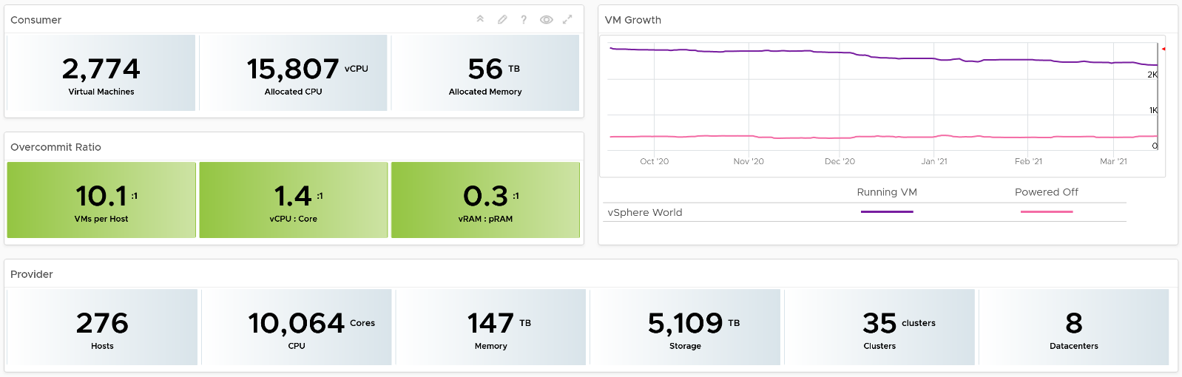
The weekly average of VM growth is displayed to provide holistic visibility of overall growth across all Data centers for both running and powered off workloads. If the increase in VM count is not accompanied by corresponding increase in utilization, these newly provisioned VMs are likely not yet used.
Overcommit Ratio highlights the efficiency gained by vSphere virtualization running multiple workloads on shared infrastructure. It is important to note that overcommitment needs to be further reviewed in conjunction with elevated resource contention (refer to contention dashboards) to understand the performance impact when running VMs competing for resources. In general, Overcommit is required to be financially more economical than the public cloud. As a reference, AWS typically overcommits CPU 2:1 by counting the hyper-threading and does not overcommit memory. Note: VCF Operations uses Physical CPU Cores not Logical Cores (Hyper-threading) for all CPU-based capacity calculations
The bottom part of the dashboard is split into 2 columns:
- compute
- storage.
Network is not added due to its nature. It’s an interconnect, not nodes, so capacity is much harder to compute.
The dashboard uses the term compute (and not vSphere Cluster) and storage (and not vSphere datastore) to keep the visual simple.
The two columns have identical design. The heat map displays capacity by size and colored by time remaining. However, for compute the size of each box in the heat map is fixed as there is no single metric to represent the size. A cluster size can be measured in 4 different ways (No of ESXi Hosts, Total CPU GHz, Total CPU cores, and Total Memory).
Here is what the compute portion looks like. The heat map is interactive. By selecting one of the cluster, you can further drill-down to clearly understand remaining capacity and time (in days).
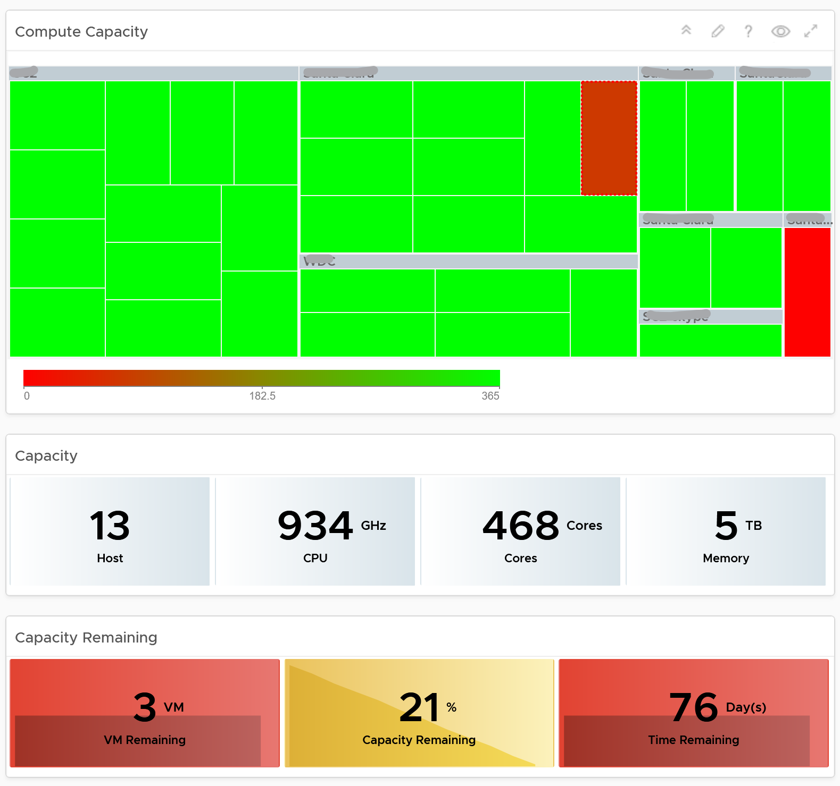
Here is what the storage portion looks like. They are designed to be similar
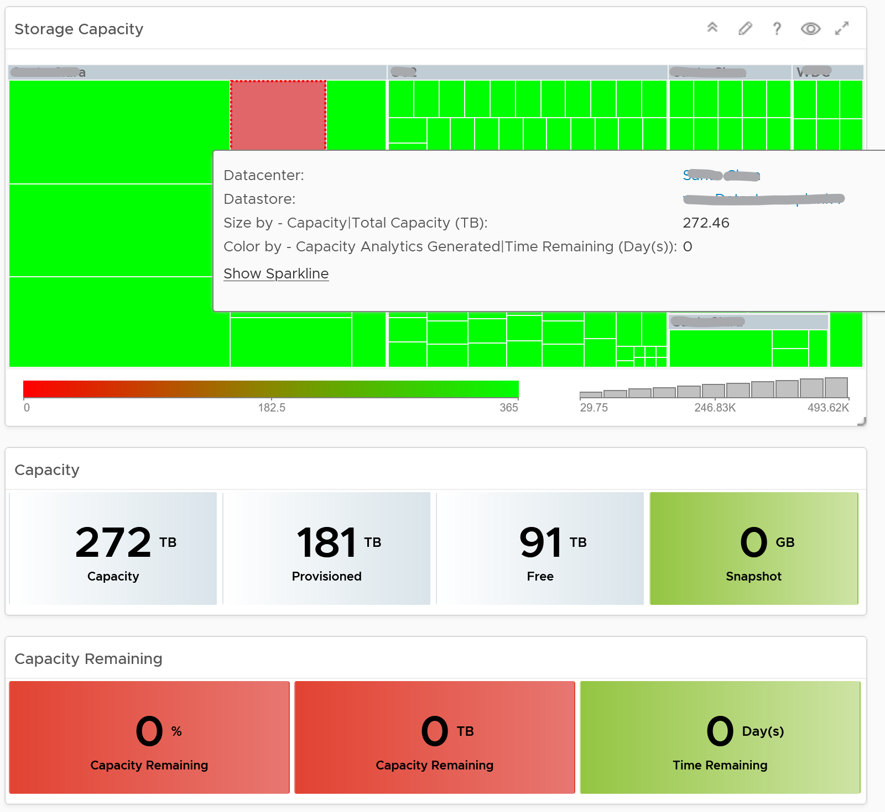

Points to Note
- Capacity Remaining is not shown at the world level as it could be misleading, especially in global or large infrastructure. Clusters also tend to serve different purpose, and they are not interchangeable.
- If you are using both on-prem and external cloud, for example, VMware on AWS, consider splitting the dashboard into 2 columns. You would need extra screen real estate though.

Reports

How can report, which is static, complement dashboard?

Report | Dashboard
The nature of report means it is better than dashboards in certain situation or use case, such as:

Offline | A typical example is the user is travelling, such as in a plane.  If the user is not offline, but has limited network bandwidth, a text-based AI-powered chat could be better than report.
Offline | Typical audience: Senior IT Leaders.
No access | The users don’t have network access or security clearance to login to VCF Operations.
No access | Typical audience: external users who cannot reach VCF Operations
Casual User | Both PDF files and CSV files require less training to users than a system. There is no login required, and usage is generally much simpler.
Export | Export into spreadsheet for further analyzis & reporting. Typically, the Finance team or Audit Team want the data as part of their spreadsheet report or PowerPoint presentation.  If it makes sense, educate and empower users on using a dashboard instead. They will need to know how to filter a table and do data transformation.
Legal requirement | Legal requirement may dictate that the information is pushed to the user.  Politically, in some situations you can say you’ve done your job when the report is delivered to the user inbox, regardless whether the user actually reads it or not.
Legal requirement | Typical audience: different legal entity. Paying customer.
Printed document | In some meetings, stack of printed documents can complement laptop as it’s easier to pass around.
Printed document | In some situations, government policy may require the report to be signed.
Printed document | Limitation: you need to manually design the widget size to fit the paper.
Historical copies | You need to keep an external copy of the data. This is applicable for functions such as capacity management and compliance management.  If you want to compare at fixed and regular intervals, such as every week from Monday 00:00 hours to Sunday 00:00 hours, then it’s more convenient via report. Comparing a specific date (e.g. each month of the year) is also easier on a report.  This is best done via a simple CSV file as files can be compared in a spreadsheet if they have identical layout. Since many historical data is stored, be specific on the information as changing the format makes comparison difficult.
Attachment | A file can easily be attached to email or other system.

Suitability
Report is not suitable for:
- Daily consumption.
If you need the information daily, you’re better off using interactive dashboard. You get richer experience this way. Even if you login once a week, consider using personalized dashboard with rich interactivity. It’s way more adaptive to your needs, which can have variations over time.
- Details.
Vast amount of data that requires analysis is better served via a set of interactive dashboards. The exception is you need free style analysis on spreadsheet.
- Dynamic time period.
Unlike dashboard, in which users can change the date and time being covered, report is fixed. To change the coverage from say 1 day to 1 week, you need to have design access and change of each widget one by one.
Because of the limitations above, report is not where you do management. However, it’s great for planning and overall review, especially long-term planning where you don’t want to be distracted with details.
Unlike dashboard, report has 2 models of consumption:
- To be read.
- To be explained.
If a report is to be read, then it must be self-explanatory.
If a report is to be presented and explained, keep the content for strategic conversations. The inability to drill down help your goal to focus on the big picture. If what you need is details, you’re better off using dashboard. In this way, you can drill down as needed to answer questions from your senior management.

Inventory | Focus on the big picture.
Availability | The goal is just to capture overall availability. Focus on the big picture. As a result, individual ESXi host availability is not suitable for reports.
Performance | Not for monitoring or troubleshooting.  The goal is just to report (proof) that performance was good. So capture the overall performance. Focus on the big picture. As a result, individual VM level performance is not suitable for reports.
Compliance | Not for remediation.  The goal is simply reporting for compliance purpose.
Capacity | The goal is for planning, not managing the capacity.  Focus on the big picture. Look ahead, preferably 1 quarter ahead.
Configuration | Use it as a backdrop on why you have configuration issues, and what can be done to address them.
Security | Not for remediation. The goal is simply reporting.

Target Audience
Report should be purpose-built, designed specifically for a persona and use case. A persona may need multiple reports, with different frequency and contents. Avoid lumping these different reports into a single report. Find out the actual, end persona.
In the product, it’s impossible to cater for everyone in all customers, so we’re providing the building block approach. You may need to combine the reports, and perhaps even customize the input and output. As a convenience, we provide some examples out of the box.
Once you know the actual human being reading the report, schedule a meet to understand the need well.

Purpose | Is it for action or just FYI?  Senior management may just want to receive, but not actually open the report on time and everytime. The report is just there for “just in case” additional details are needed.
Next Step | If it’s for action, it must not be time sensitive (within the day). For daily information, the users are better off served by dashboard. Exception is they need to export to spreadsheet for further integration
Timeline | How frequent do they need it?  The longer the timeline, the less fresh the information becomes, so the focus needs to shift towards the bigger picture.  The longer the timeline, the higher the chance the recipient forgets the previous value, so you might have to repeat and compare current and previous.
Timeline | Past focus or future focus?  This requires brainstorming as users typically ask for historical data, while their intent is for future.
Timeline | The main limitation in report is the time period needs to be hardcoded in the widget. Unlike dashboard, report does not have date control at the report level.
The most common persona for report is IT senior management. As their requirements are comprehensive, they are documented separately in the Role-based Contents chapter.

Auditor
Majority of their needs are better addressed by dashboard.
This role is interested in knowing that the environment is kept secured. They also want to know if there are unauthorised changes, especially by privileged users (read: system administrators, yes, that means you and your team).
Report Frequency: Weekly – Monthly.

Capacity Planning Team
Majority of their needs are better addressed by dashboard.
There are several use cases where report is better than dashboard. They may need to keep historical data for years, to enable more accurate long-term planning. Having the record of each data center, cluster and datastore can be handy. This should be provided as simple CSV files.
Report Frequency: Weekly – Monthly.

Finance Department
They typically prefer information in a spreadsheet, so they can use it as part of their financial analyzis and reporting.
As they care about asset, only information about hardware is relevant. For example, a list of ESXi host with their purchase date, end of warranty, and cost.
Report Frequency: Weekly – Quarterly.

Tenant
In some organisations, it can be effective to send regular emails on reclamation to the respective owner. While the owner has access to a self-service portal, they may react differently as the email is cc-ed to their senior leadership and Office of the CFO.
It’s also useful and make actionable request highly visible to the broader team. The email can consist of Top 10 VMs, with the VM owner name, with the largest cost savings potential.
Report Frequency: Weekly – Monthly.

Consultant
This is a special kind of report for 2 reasons:
- The nature is comprehensive, covering all aspects of operations management.
- Typically, the consultant conducts an assessment and need to produce report. This assessment is done rarely, such as once a year.

Technical Considerations
Once the target audience and purpose are defined, the report design consideration comes into play:

Scope | Is it the whole environment or a subset? The amount of data can impact your choice of visualization. For example, while a table can handle 100 rows well, 10K rows results in endless pages.  In a large environment with thousands of vSphere Clusters and datastores, the data at world level may be too high. The scope impacts the type of information shown.  One way to address is to focus on the exception or important. For example, when listing VM to downsize, only focus on large VMs.
Scope | The above translates into what objects to use. In general, we use vSphere World, vCenter and vCenter DC as the scope. This means the content is from lower-level objects.
Layout | For consumption on a laptop or desktop, a landscape will suit user better. This is why the default report is all landscape.
Layout | For consumption on a mobile phone, a portrait fits how a user holds her phone.  For consumption on a tablet, it depends on the size of the tablet.
Color | A report that is color coded will be easier to read.
Data Recency | Present value vs past value.  There are use cases for both.
Data Recency | The present data point is relevant when you need to know the current or latest situation.
Data Recency | The historical data points are more relevant when you need to analyse over a period. Since there are more than 1 data points, you need to pick 1 to represent them. Typically you take the maximum, average, or percentile. If you need to present a pattern or trend, you plot a line chart.

Output
There are 2 types of outputs:
- PDF
- CSV

CSV | Only the view list is suitable.  While Summary List can produce CSV output, the content lacks details for further analysis. So use it in PDF output, as you likely need another widget to show detail
CSV | The page orientation is also not relevant. You can go as deep and as wide as you want.
CSV | 1 report per object. CSV file cannot support tab. 1 file only has 1 table or list.
CSV | Do not color code as it will be ignored by the plain CSV format.
CSV | Do not group the output, as it’s better to use a spreadsheet to group.
CSV | While you can add a summary row at the end, it’s more flexible to use spreadsheets as you can have different formula for each column.
CSV | There is a limit of 50 columns. For object with many metrics and properties, logically separate them.
CSV | For utilization and contention, show at 95th percentile. Maximum will likely show outlier while average is “too late” as the goal is to serve everyone almost all the time.
CSV | For event, sum the numbers. For example, the number of Guest OS rebooted.
PDF | Design the report to use landscape orientation. This makes it suitable for laptop, tablet and printed paper.
PDF | Just like mobile phone friendly app is best designed separately, the same goes for report. The small screen requires a purpose-built design.

Context
Put a context. It helps when the CSV file contains thousands of rows. For example, for VM, add the following columns. I put them at the end as the first few columns should be more important information and used for sorting.

Column 1 | The parent vCenter Data Center.  This is the first column, so the VM is “grouped” by DC.
Column 2 | The parent vSphere Cluster.  This is the second column, so the VM is “grouped” by cluster.
Column 3 | The parent folder.  This is the third column, so the VM is “grouped” by cluster

Widgets
Only a handful of widgets are suitable for PDF printed report, because reports have no interaction and fixed height.
A report should flow from summary to details.
- Start with headline numbers. This shows large, eye-catching number.
- Break down the headline numbers by groups. The focus is on the groups, especially their relative size or value.
- Show trend over time, if the pattern is important.
- Last is show the individual members. To focus on the important ones, limit to say top 10.
The following shows the various section and the widgets suitable for it.
By being aware of the limitations of each widget in PDF layout format, you avoid redoing your report. Measure twice, cut once.

Purpose | Description
Headline | Large font, eye catching. 3 – 5 numbers shown on portrait paper visualize the summary well. If you put too many it will look crammed. If you put 1 – 2 numbers it will look incomplete and sparse.
Headline | Widget: Score Board.  Limitation: score board can only show present value, hence not suitable for performance.
Summary | A simple table. Use when you need to summarize values of many members at the parent level. It complements the score board widget as you can do computation.
Summary | Widget: Summary View.  Limitation: The filter applies to all rows in the table, despite the fact each row has different metrics. There is no count function. Only sum, maximum, minimum, average and standard deviation
Grouping | Show objects by group. Focus is on the group, not the individual members.
Grouping | Use Pie Chart when you don’t know how many slices as it’s dynamic. Value wise, pie chart is good for relative distribution. Its focus on relative means it’s less suitable for performance management.  Limitation: Legend gets truncated easily unless it’s short.
Grouping | Use Bar Chart when you need to control the range of each slice, or focus on the quantity of each slice. Value wise, bar chart is good for absolute distribution.  Limitation: Need to manually set the number of buckets for best visualization
Grouping | Use Heat Map when you need to show relative size and intensity. For the color, heat map is the only widget capable of showing continuous gradient of values.  Limitation: The group name is hard to read if there are too many groups
Trend | Shows trend line. Focus on pattern over time.
Trend | Health Chart. Use when you can color code the value.  Limitation: The shortest height is too small. Use the medium or tall option instead. It is less suitable if the number of objects is not fixed. Visually, there is no control for the y-axis minimum and maximum value.
Trend | View Trend. When values can’t be color coded, and you need multiple lines on the same y-axis for comparison.  Limitation: Quite tall, taking up sizeable page. Since your report is landscape, try to put 2 side by side.
Individual | Individual means listing each object on the report, with their names.
Individual | Top-N. This is a simplified table. Focus on the value of 1 metric. Best when the relative values among them matter and you can color code. Use the Percentile function as the default roll up is average  Limitation: Set the number of rows, so it’s only suitable for items when this number can be capped without losing meaning
Individual | View List. This is a multi-column table. Focus on the object name.  View can show before vs after. The limitation is the time setting is hardcoded in the view. Users without designer access cannot modify it.

Functional Considerations
Let’s summarise the applicability of present value vs past value.

 | Present Data | Past Data
Inventory | Yes | Yes
Availability | No | Yes
Performance | No | Yes
Compliance | Yes | Yes
Capacity | Yes | Yes
Configuration | Yes | Yes
Cost | Yes | Yes
For historical data, you need to hardcode the time period on each widget.
Since Performance and Availability requires data across time, not all widgets can be used. Specifically, the following widgets are not suitable:
- Scoreboard
- Heat Map

Synergy
The reports were designed together as one suite. As a result, none of them is independent as we minimize overlapping content. Run the reports as a set.
Let’s take an example on how they synergise. Inventory, Configuration, and Capacity synergize to provide complete coverage.
- Configuration is about settings of that object.
- Capacity is about size. It also tends to use line chart, so it can show changes or pattern over time.
- Inventory is about count. It focuses on the type of sizes, not the actual size. It’s showing the most common ones. The goal is to know the variation.
Let’s take VM configured size for example.

Inventory | It reports how many sizes you have, and which ones are the most popular size. Are the common sizes larger or smaller than your expectation?  It’s using a pie chart as it’s about relative distribution and the number of the variations.
Configuration | It reports the sizes in order, so you focus on the monster VMs.  It’s using bar chart, with buckets filtering out the small ones, focusing on the large configuration.
Capacity | It reports the undersized and oversized VMs.  It’s using bar chart, but the bucket shows the range of undersized – rightsized – oversized.  For details, you can use a table to show the top 10 VMs to be acted upon.

Let’s take ESXi host for example:

Inventory | Relative distribution of ESXi by vendors, server type (blade, rack mount), server generation.
Configuration | Absolute distribution of ESXi by version, by CPU model and generation.
Capacity | Absolute distribution of ESXi by CPU Size, by memory size.

Let’s take vSphere Cluster for example:

Inventory | Bar chart of clusters, grouped by number of VM. You determine the value of each bar.
Configuration | Bar chart of clusters, grouped by number of ESXi host  The number of VM is not part of a cluster configuration.
Capacity | Bar chart of clusters, grouped by size. For example, you group them into 5 buckets of size based on total memory capacity.

Overall Design
Executive Summary | 1 summary report.  Designed to be presented by someone familiar with the environment, not self-reading by the IT leaders.  The content focuses on the big picture. It is to facilitate discussion on major initiative. It does not contain detail.
Operations Management | 1 set of reports, covering inventory, capacity, performance and configuration. Run them as a set.
Spreadsheet Export | 1 CSV export per vSphere object type. Run as needed.

Executive Report
They may not be familiar with the environment, so the report starts with key inventory.
It avoids the use of technical jargon, unless the generic term causes confusion.
It does not have details. As a result, it does not cover individual items. This means it does not list the names of any VM, clusters, datastore, etc.
Customisation tips:
- If the context allows, put items you want their approval at the top. For example, you need to get budget for technology refresh on ageing hardware.

Operations Management
For the Operations Management, the 4 reports have similar table of content.
- Consumer: VM
- Provider: Compute
- Provider: Storage
- Provider: Network
Depending on the number of pages, the above maybe further split or combined.
Based on the above, we end up with the following “section” across 4 reports. Each section, which is technically a dashboard, may span multiple pages.

Report | Consumer | Provider
Inventory | VM Inventory | vSphere Inventory
Performance | VM Performance | vSphere Compute Performance
Performance |  | vSphere Storage Performance
Capacity | VM Capacity | vSphere Compute Capacity
Capacity | Reclaimable Capacity | vSphere Storage Capacity
Configuration | Guest OS Configuration | ESXi Hardware Configuration
Configuration | VM Configuration | ESXi Software Configuration
Configuration | VM Size Distribution | vSphere Cluster Configuration
Configuration |  | vSphere Network Configuration

Thanks Darren Farrer for the collaboration.

